**Skills and Their Impact**

**Introduction**

**Impact**

**Conclusion**

Verification of Skills <https://www.credly.com/users/jude-kisang-asongwe.e127fdc2>

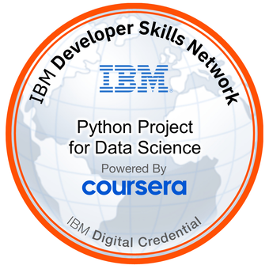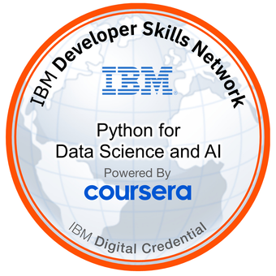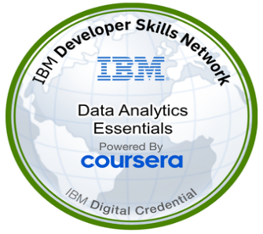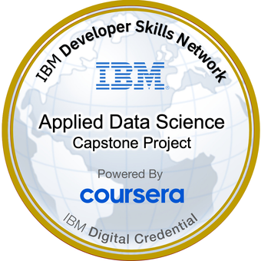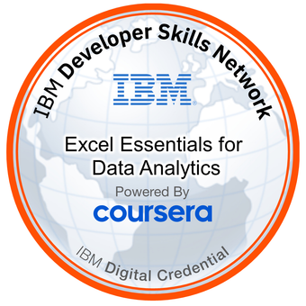

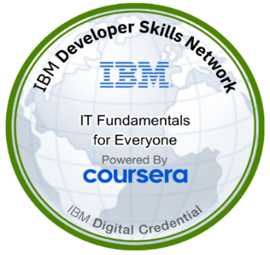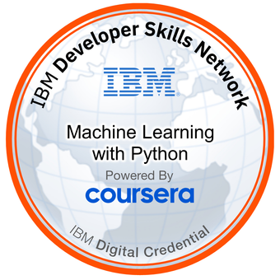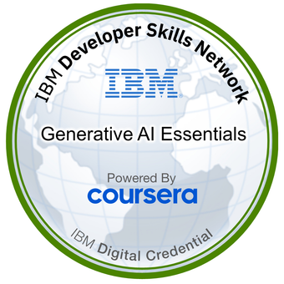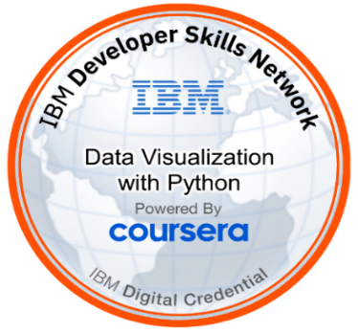

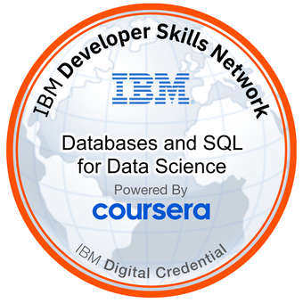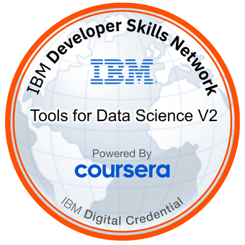 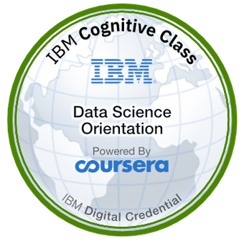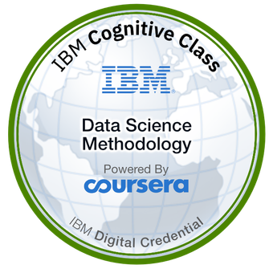

**Certificate Verification:** [**https://www.coursera.org/account/accomplishments/professional-cert/JC59364ZUVG6**](https://www.coursera.org/account/accomplishments/professional-cert/JC59364ZUVG6)

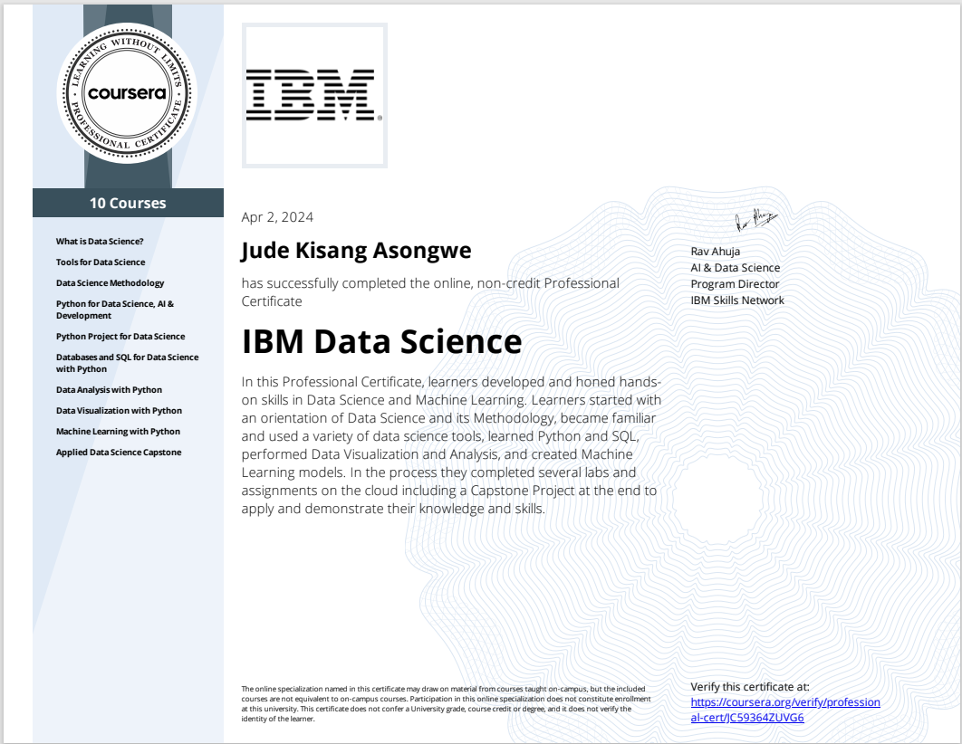

**Certificate Verification at** [**https://www.coursera.org/account/accomplishments/verify/5QWJNZ7VK5DA**](https://www.coursera.org/account/accomplishments/verify/5QWJNZ7VK5DA)

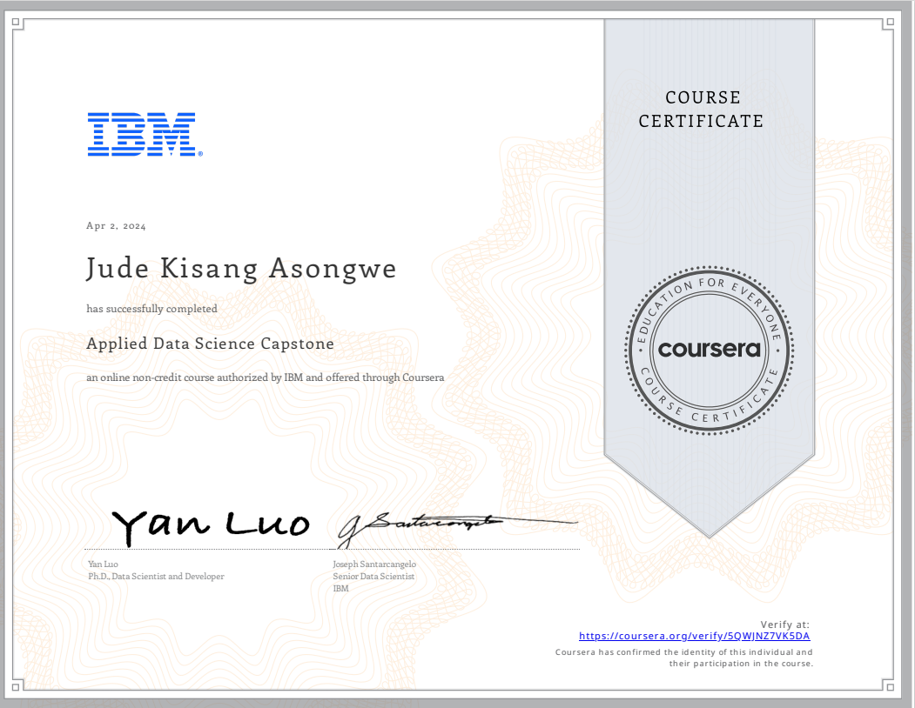

**Certificate Verification:** [**https://www.open.edu/openlearn/blocks/ocwstatement/statement.php?id=6371&user=4186593&f=1**](https://www.open.edu/openlearn/blocks/ocwstatement/statement.php?id=6371&user=4186593&f=1)

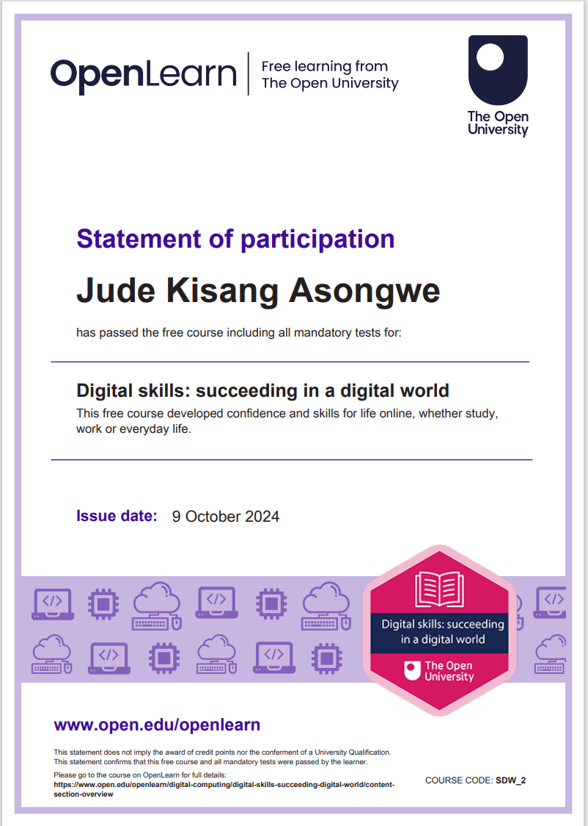

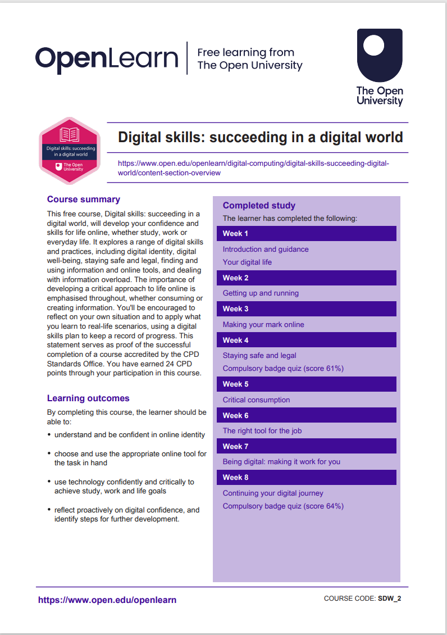

**Certificate Verification:** [**https://certificates.mooc.fi/validate/8tsn9bvhzrp**](https://certificates.mooc.fi/validate/8tsn9bvhzrp)

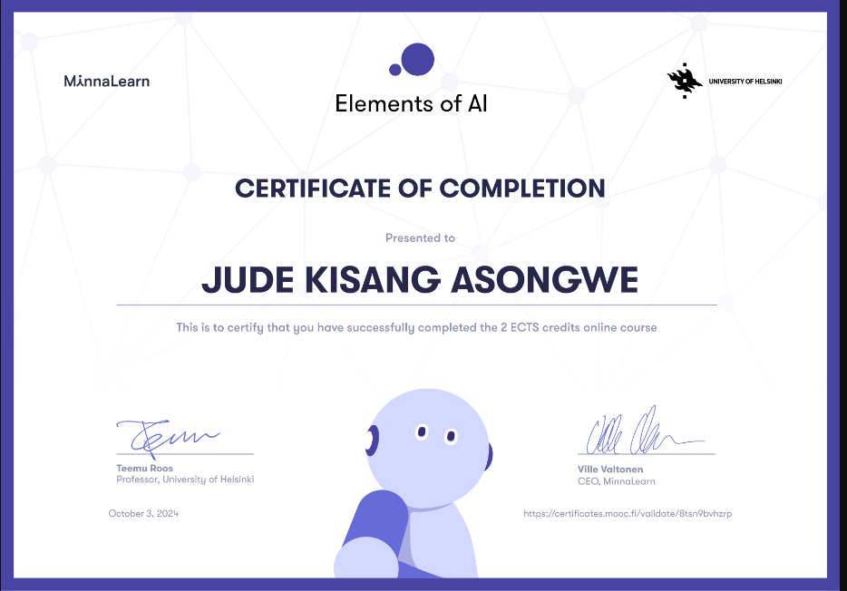

**Certificate Verification:** [**https://www.coursera.org/account/accomplishments/verify/VHPUNZ53LQJS**](https://www.coursera.org/account/accomplishments/verify/VHPUNZ53LQJS)

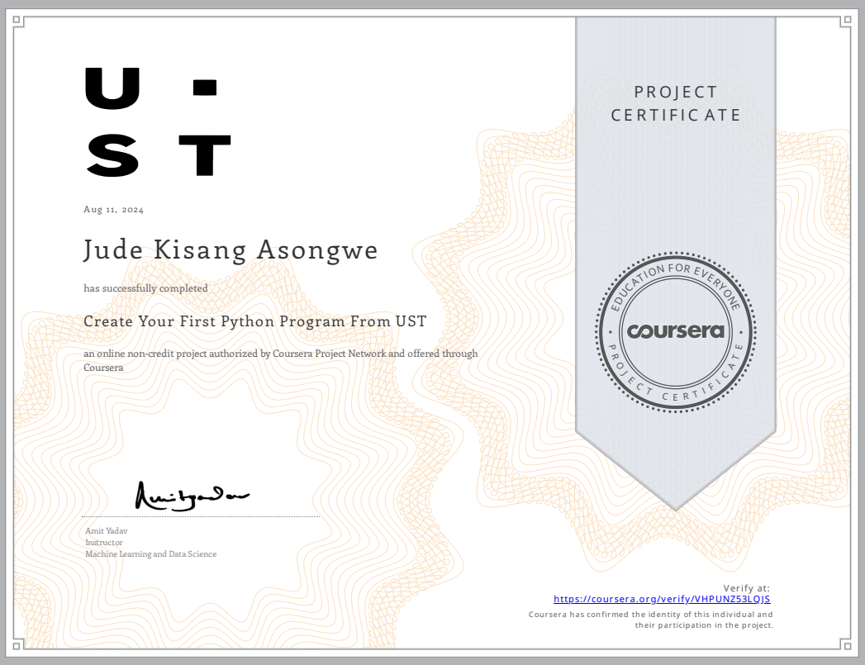

**Certificate Verification:** [**https://www.udemy.com/certificate/UC-64004c60-e6e9-4716-9e36-4eb89016f595/?utm_campaign=email&utm_medium=email&utm_source=sendgrid.com**](https://www.udemy.com/certificate/UC-64004c60-e6e9-4716-9e36-4eb89016f595/?utm_campaign=email&utm_medium=email&utm_source=sendgrid.com)

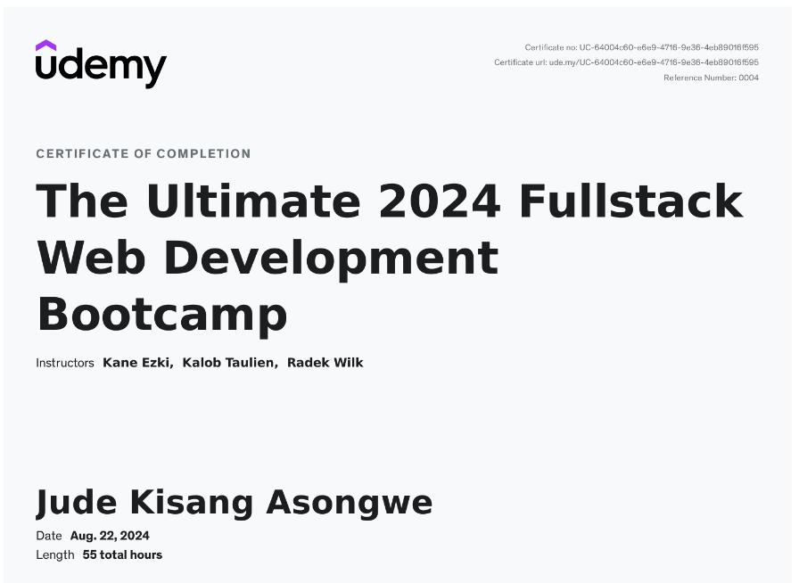

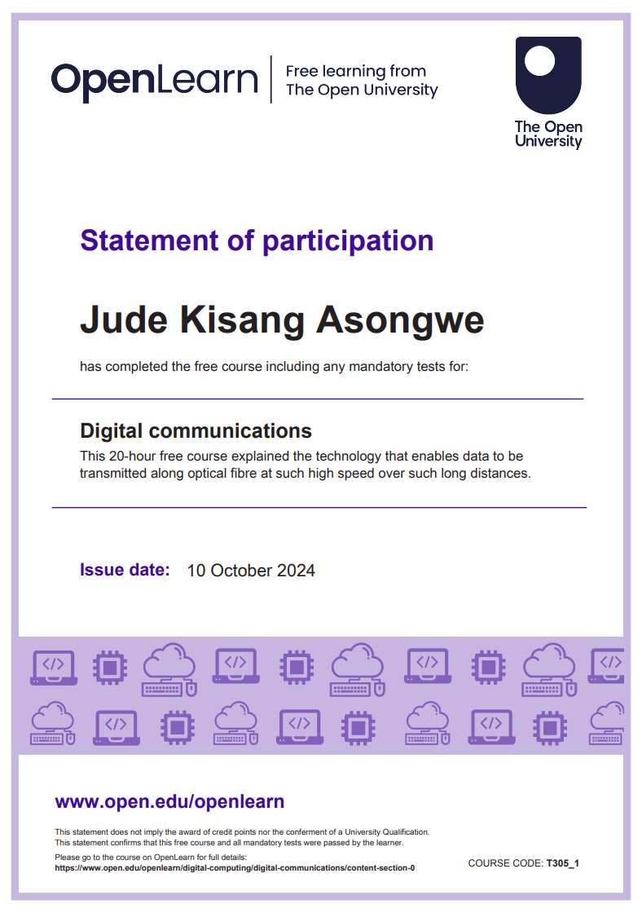

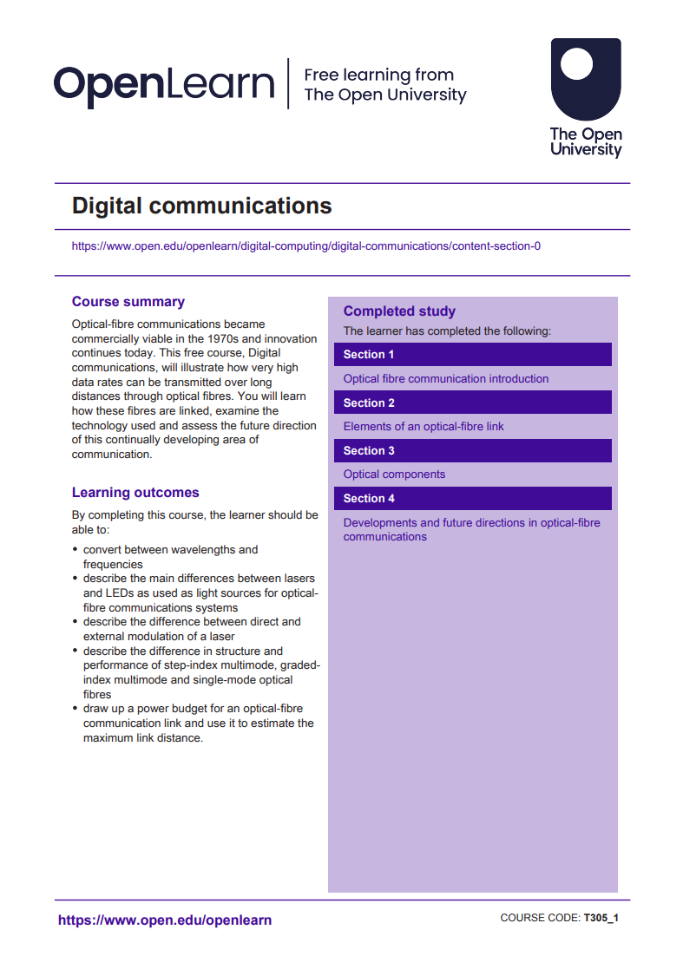

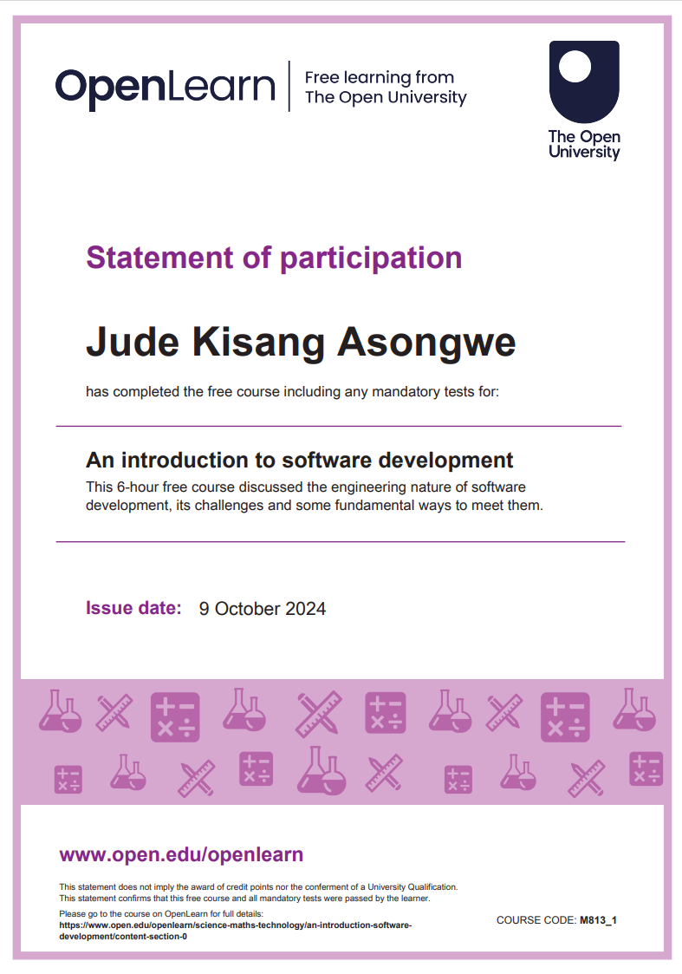

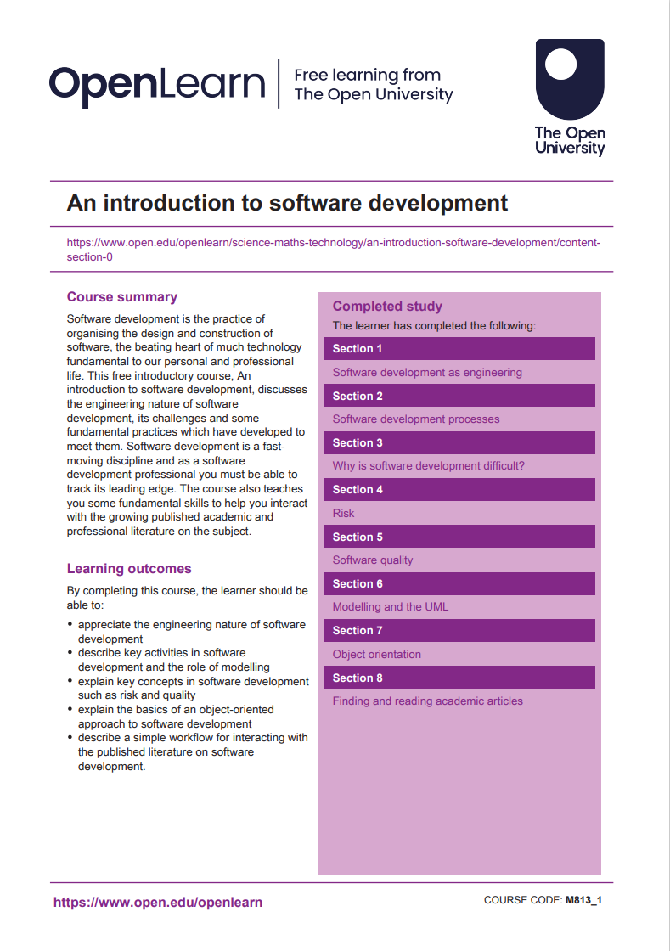

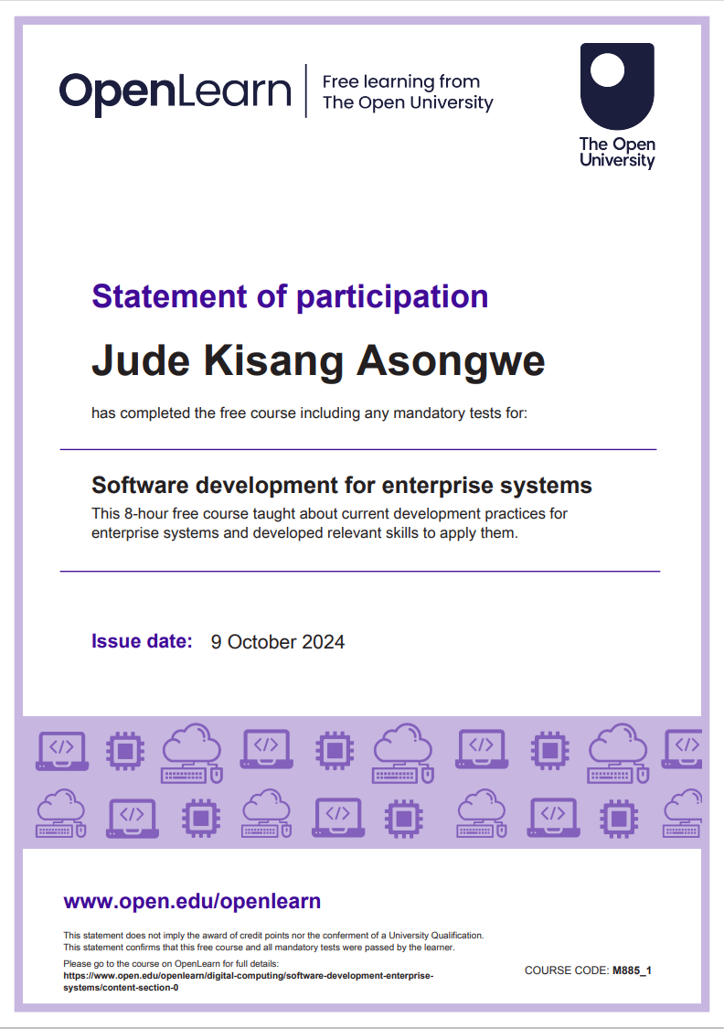

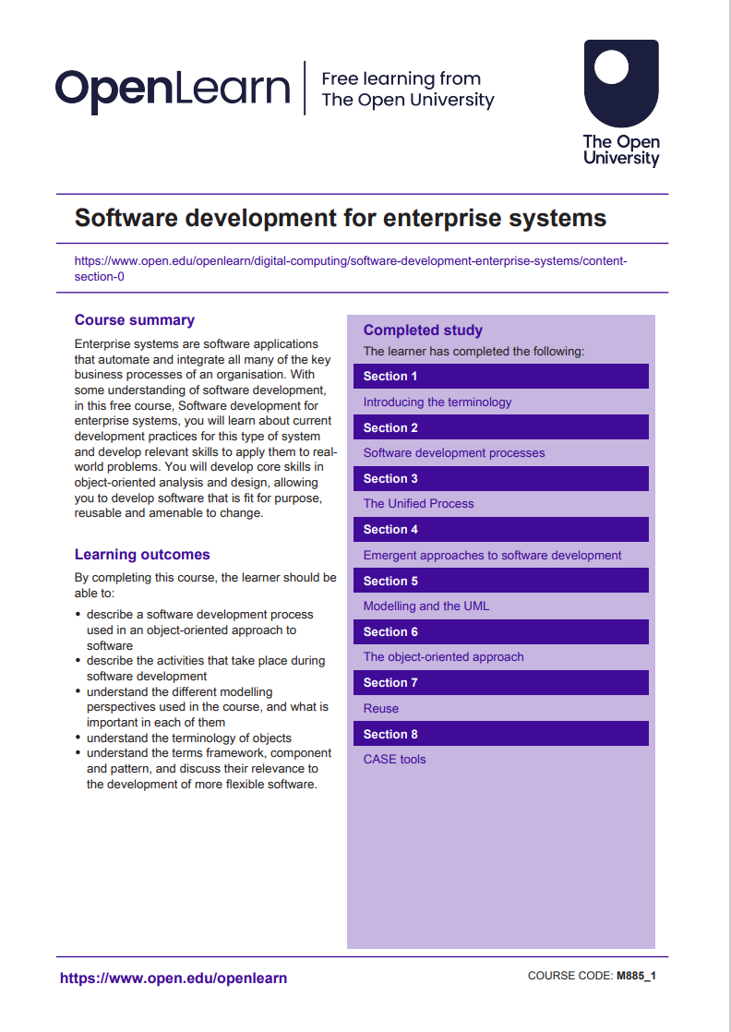

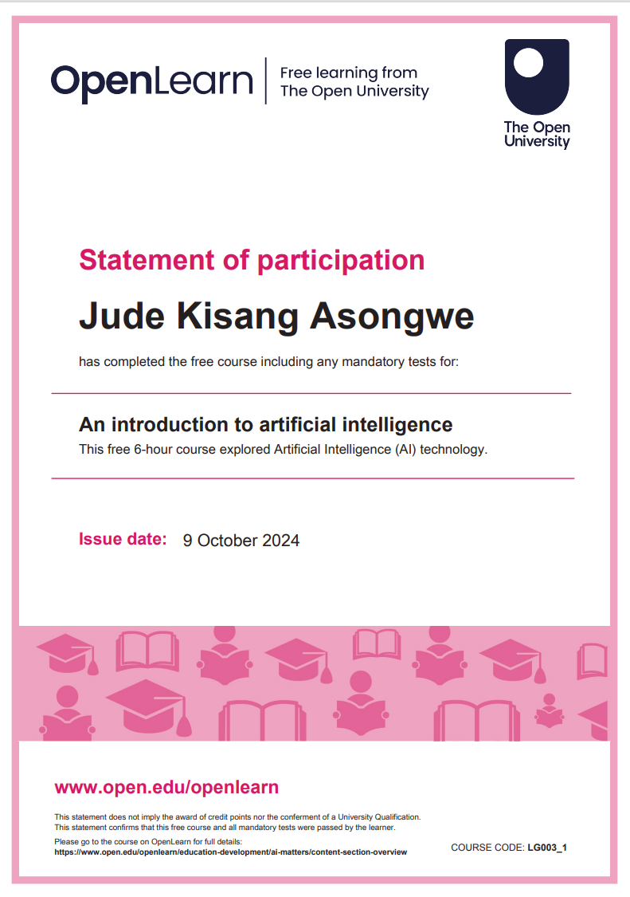

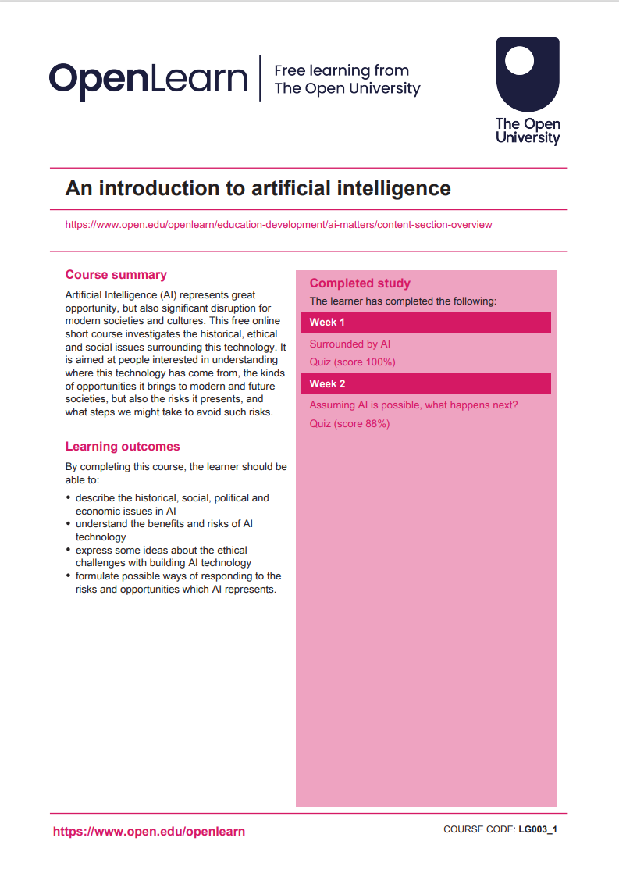

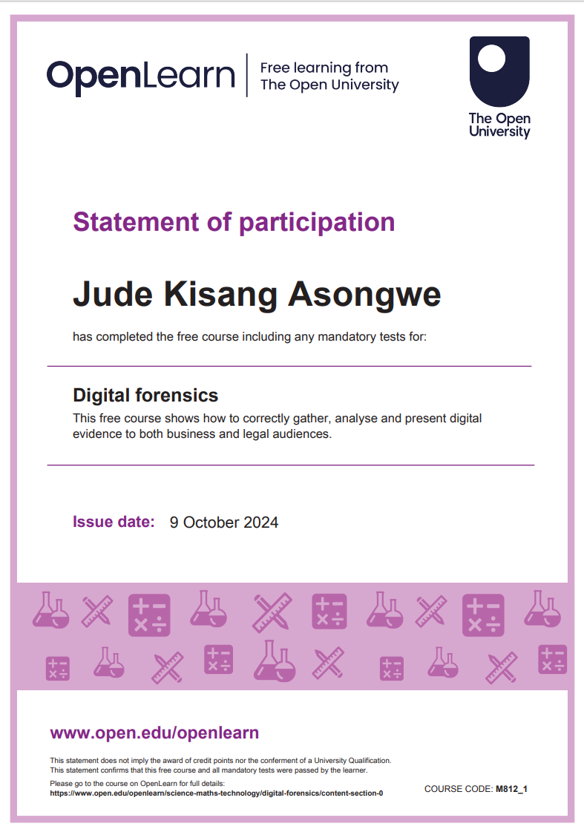

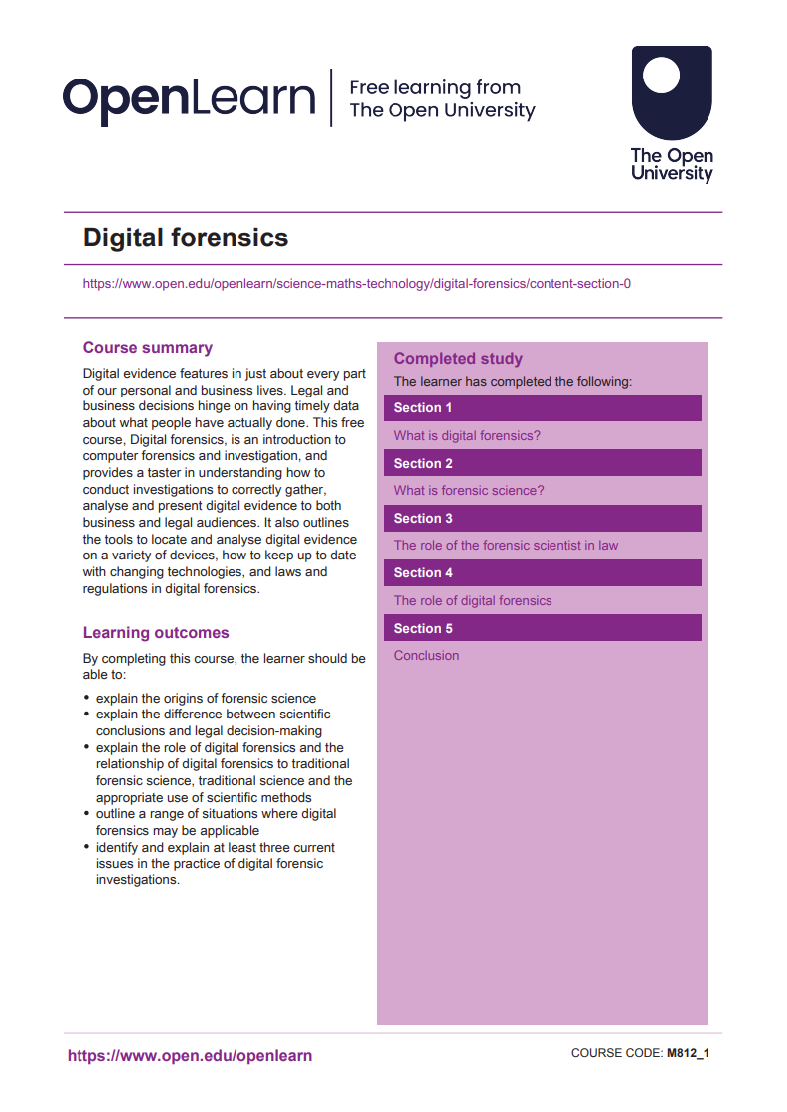

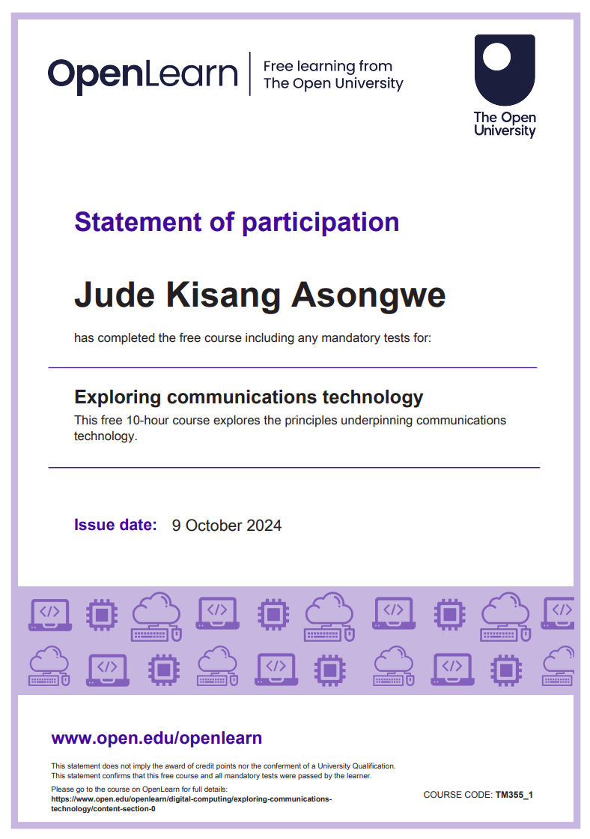

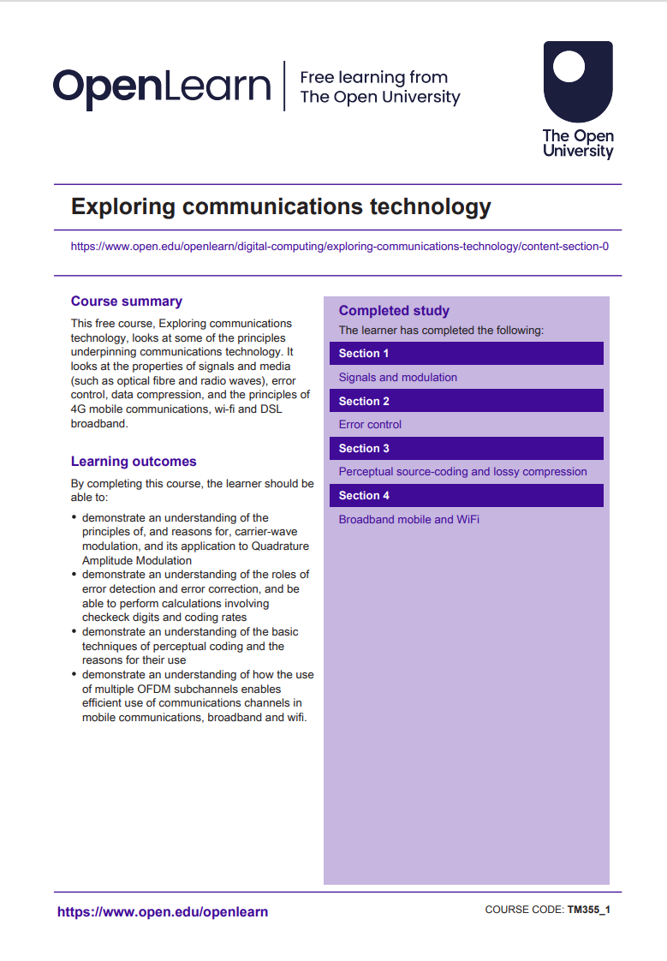

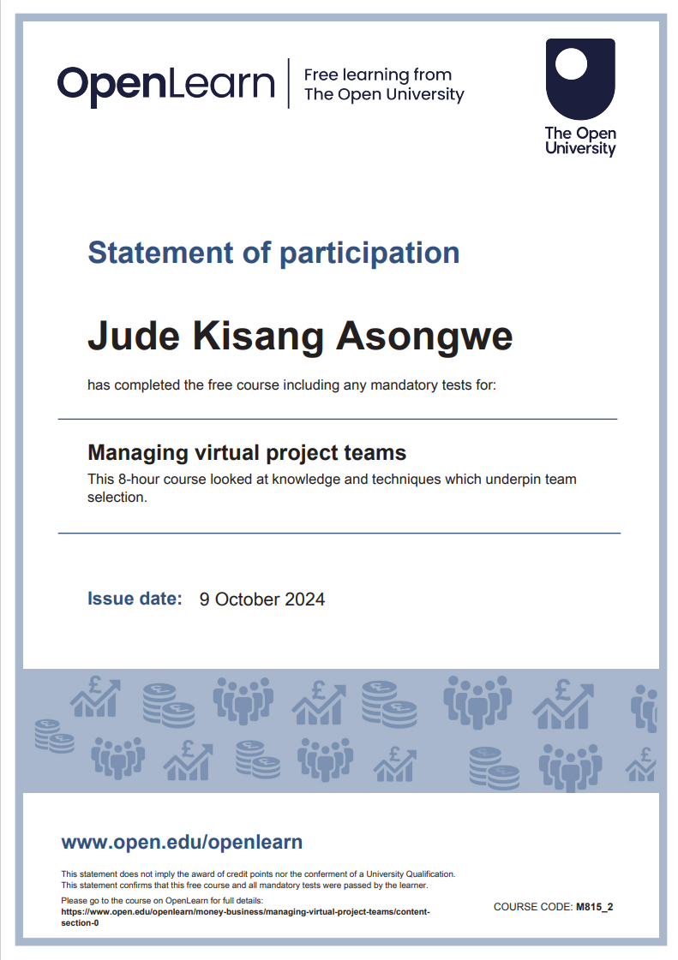

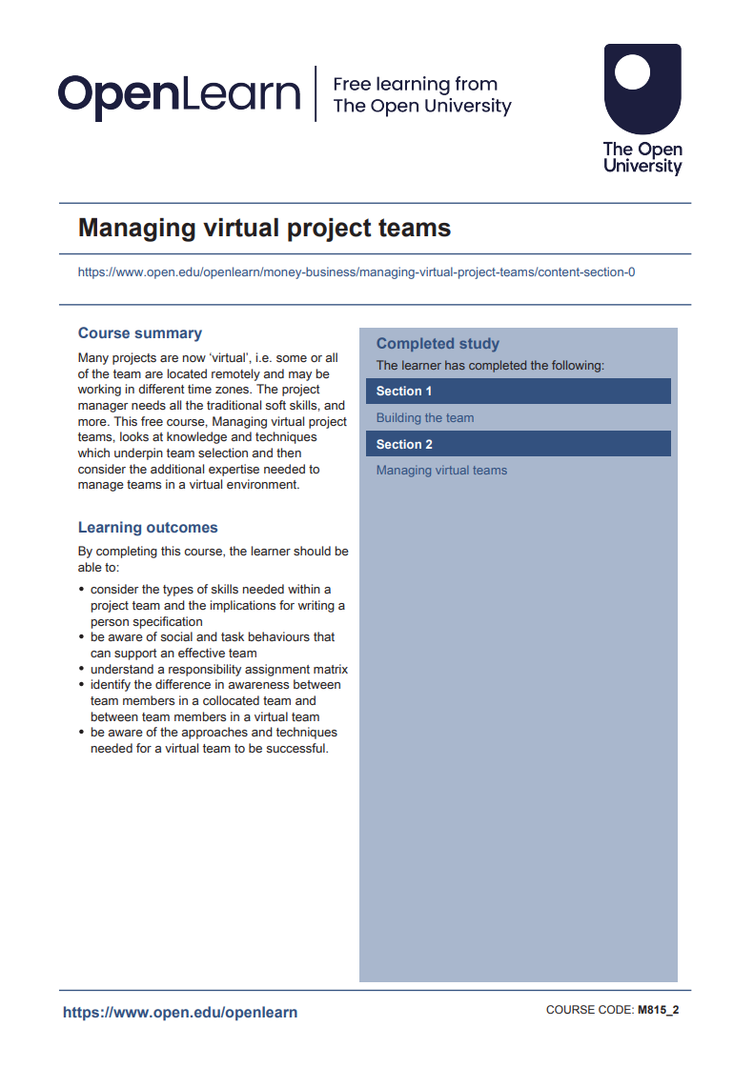

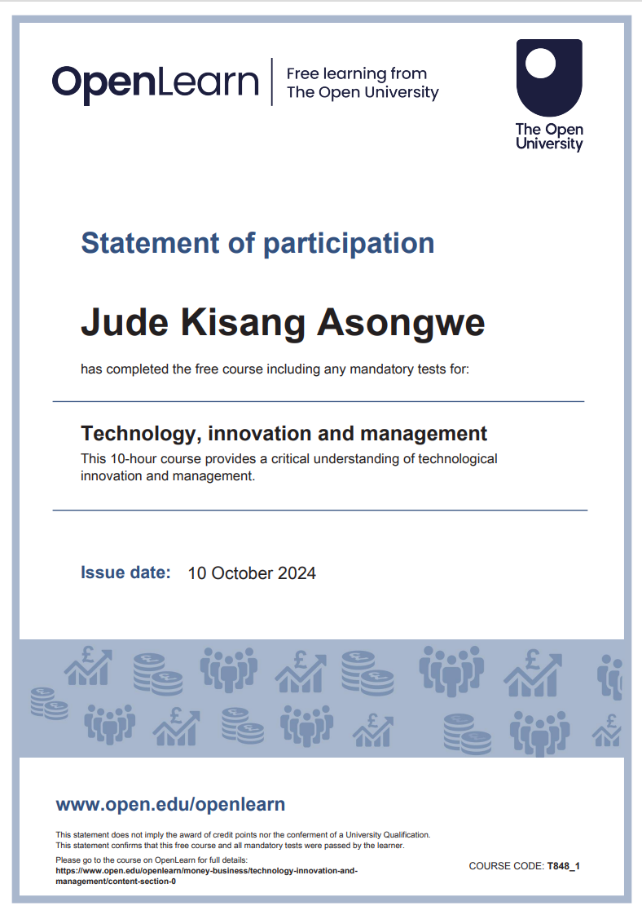

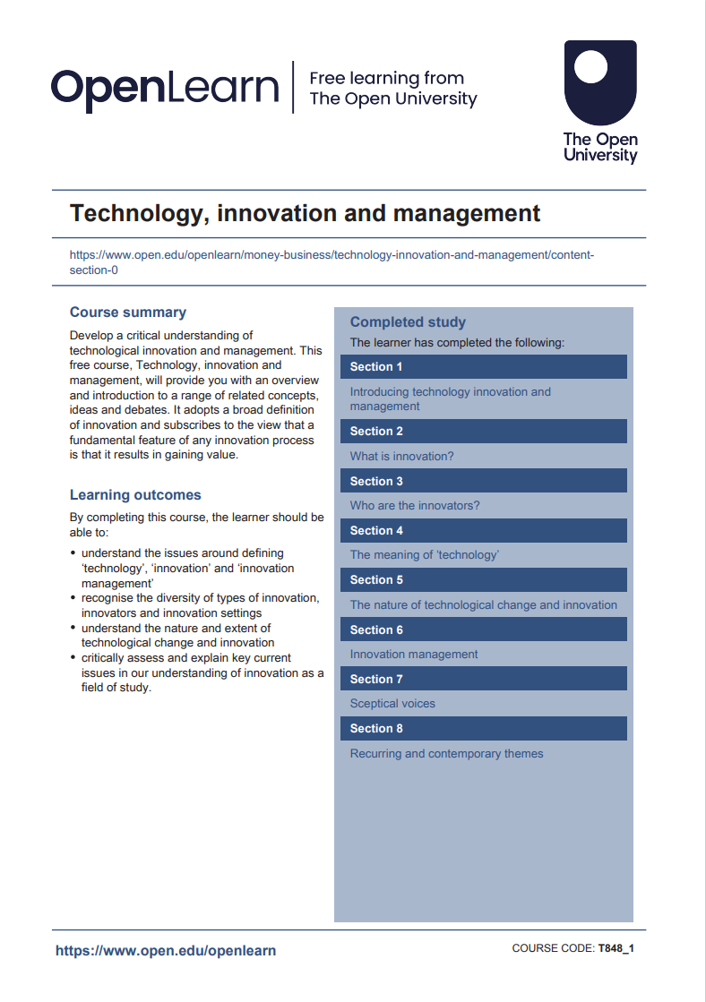

**Certificate Verification:** [**https://cursa.app/en/my-certificate/cert99a399df528559676160440444ac2585**](https://cursa.app/en/my-certificate/cert99a399df528559676160440444ac2585)

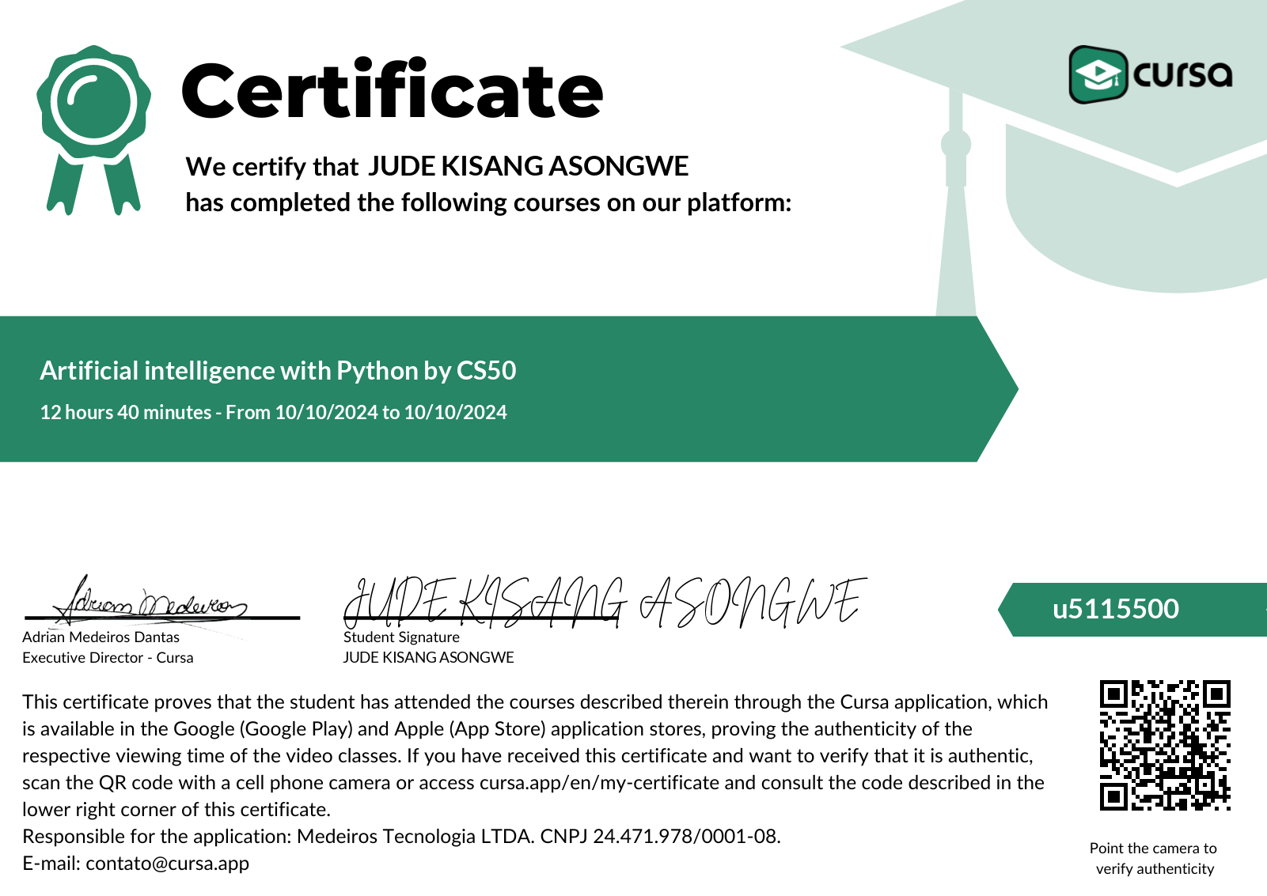

**Certificate Verification:** [**https://cursa.app/en/my-certificate/cert1ac5ec8b18f937aed1876050f314e790**](https://cursa.app/en/my-certificate/cert1ac5ec8b18f937aed1876050f314e790)

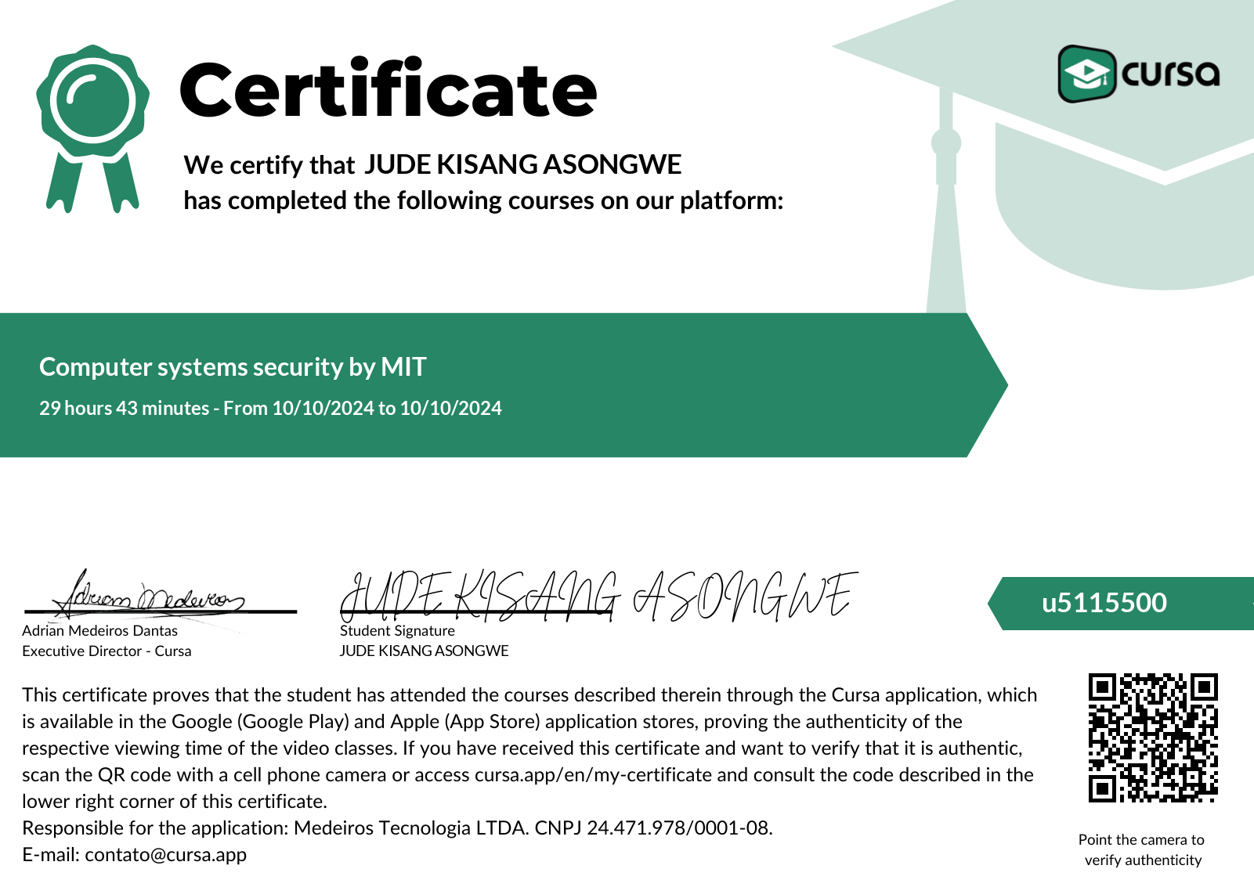

**Certificate Verification:** [**https://cursa.app/en/my-certificate/cert6e8400ef3ad23b17c0708a76dac3ed79**](https://cursa.app/en/my-certificate/cert6e8400ef3ad23b17c0708a76dac3ed79)

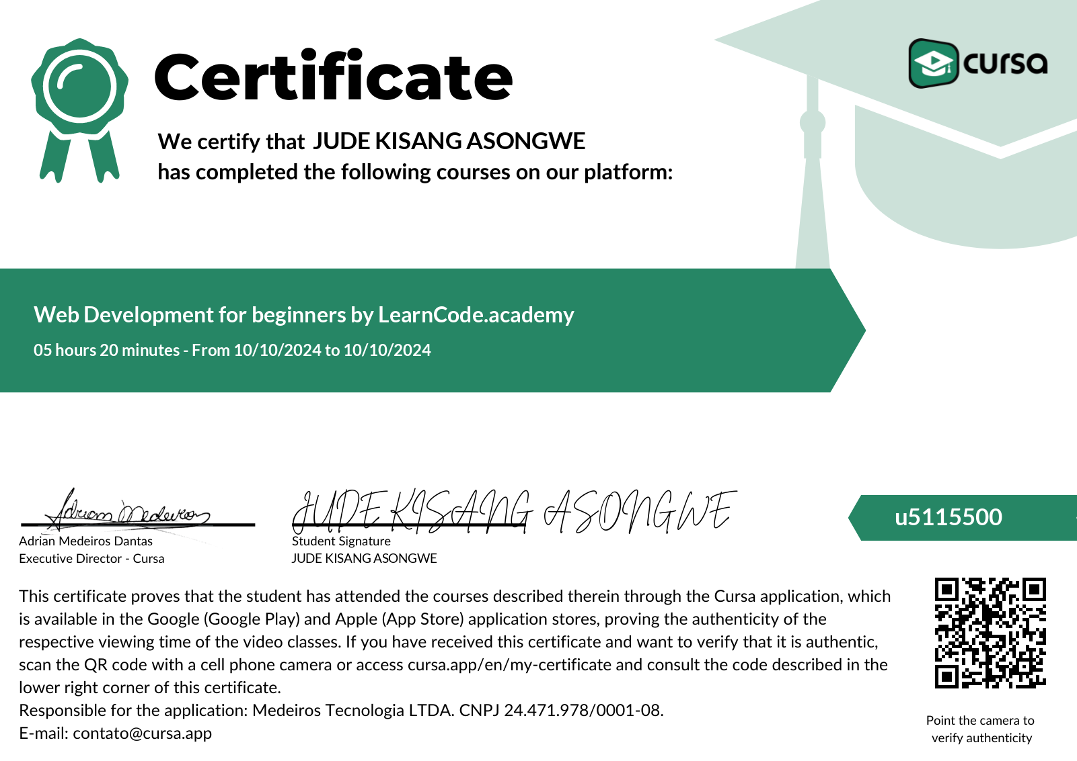

**Certificate Verification:** [**https://www.coursera.org/account/accomplishments/verify/GKULHF1GO0RM**](https://www.coursera.org/account/accomplishments/verify/GKULHF1GO0RM)

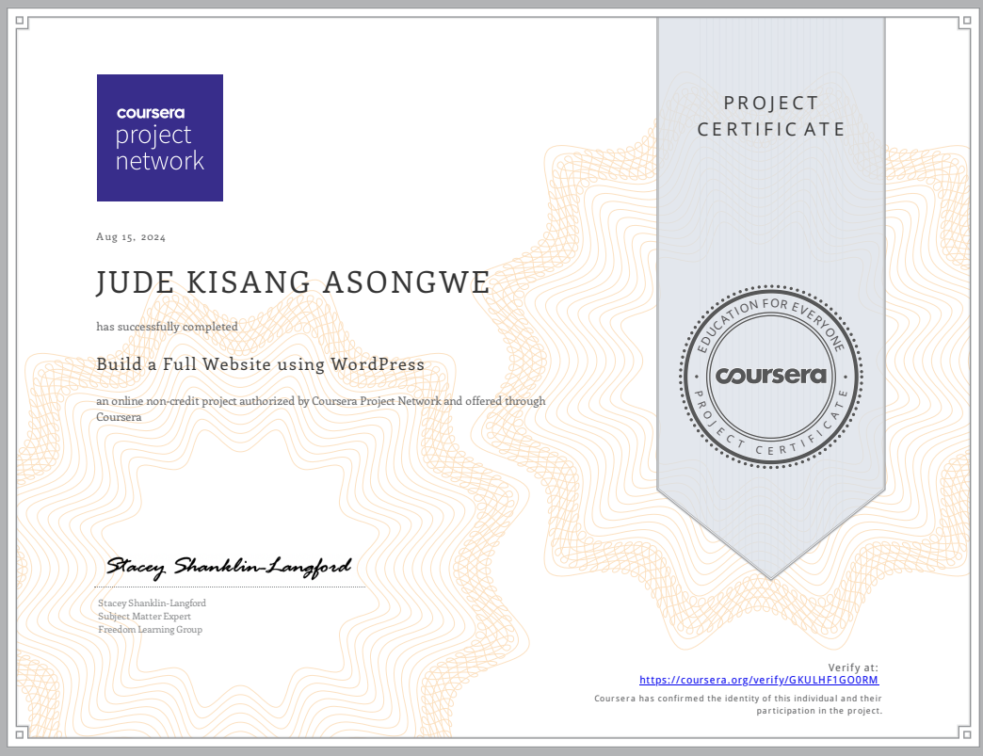

**Certiicate Verification:** [**https://www.coursera.org/account/accomplishments/verify/KA8PRVBQCNSA**](https://www.coursera.org/account/accomplishments/verify/KA8PRVBQCNSA)

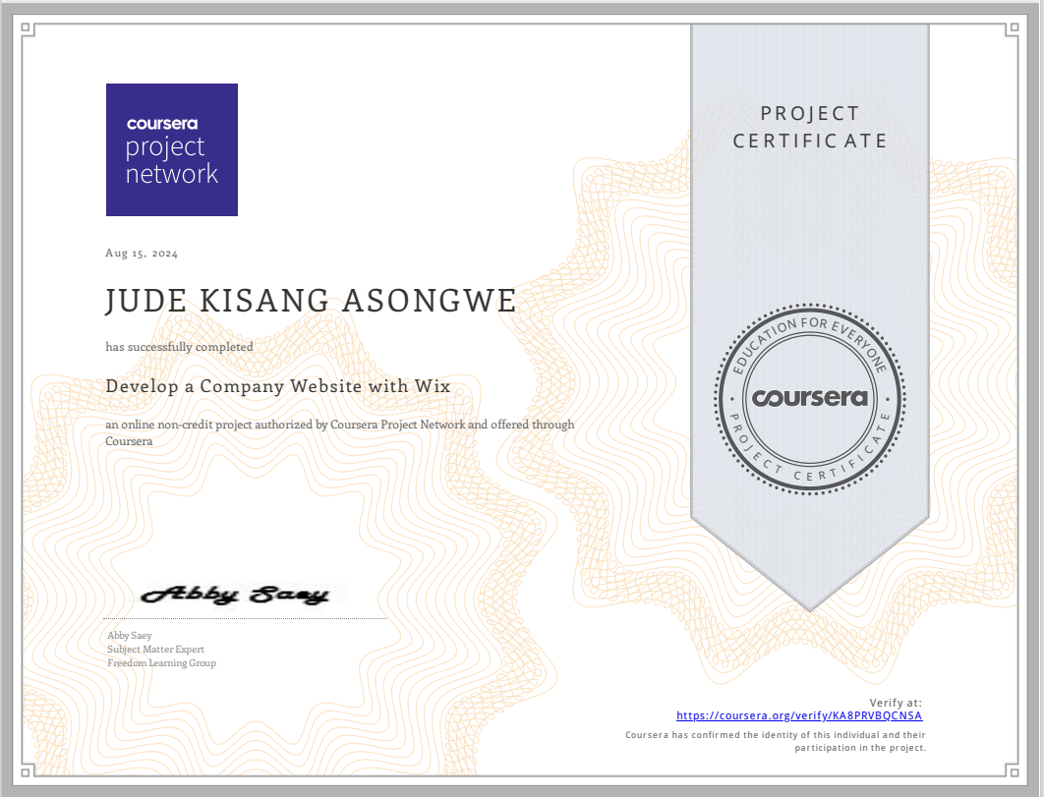

**Certificate Verification:** [**https://app-eu1.hubspot.com/academy/achievements/zpqh6sgj/en/1/jude-kisang-asongwe/digital-marketing**](https://app-eu1.hubspot.com/academy/achievements/zpqh6sgj/en/1/jude-kisang-asongwe/digital-marketing)

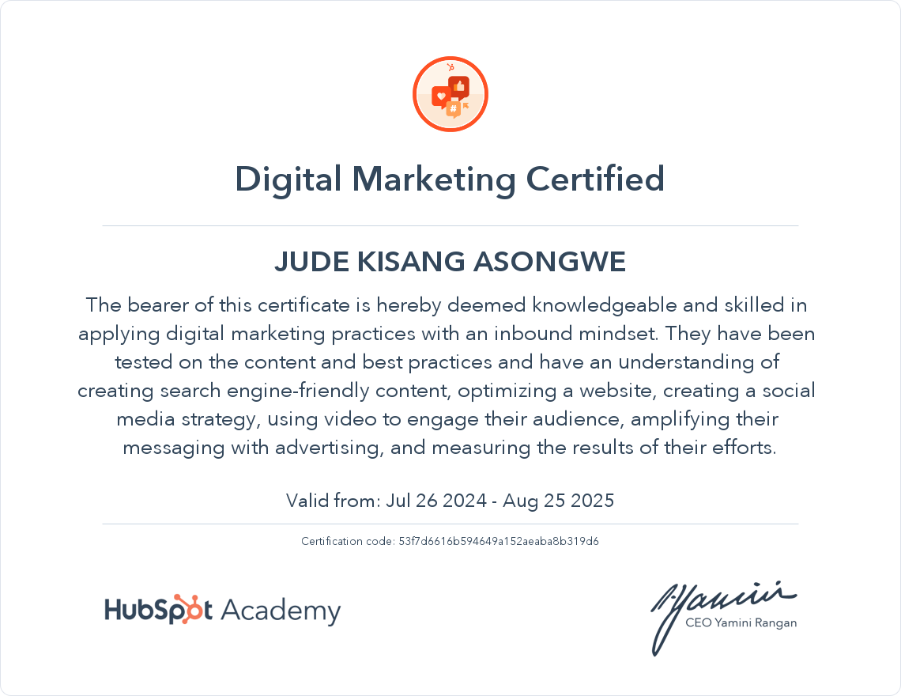

**Certificate Verification:** [**https://lloydsbankacademy.percipio.com/courses/4c1b7754-76eb-420c-8d69-521af23a737a/videos/8d4666e7-0b8f-45a5-805e-6f8fb7c951a6**](https://lloydsbankacademy.percipio.com/courses/4c1b7754-76eb-420c-8d69-521af23a737a/videos/8d4666e7-0b8f-45a5-805e-6f8fb7c951a6)

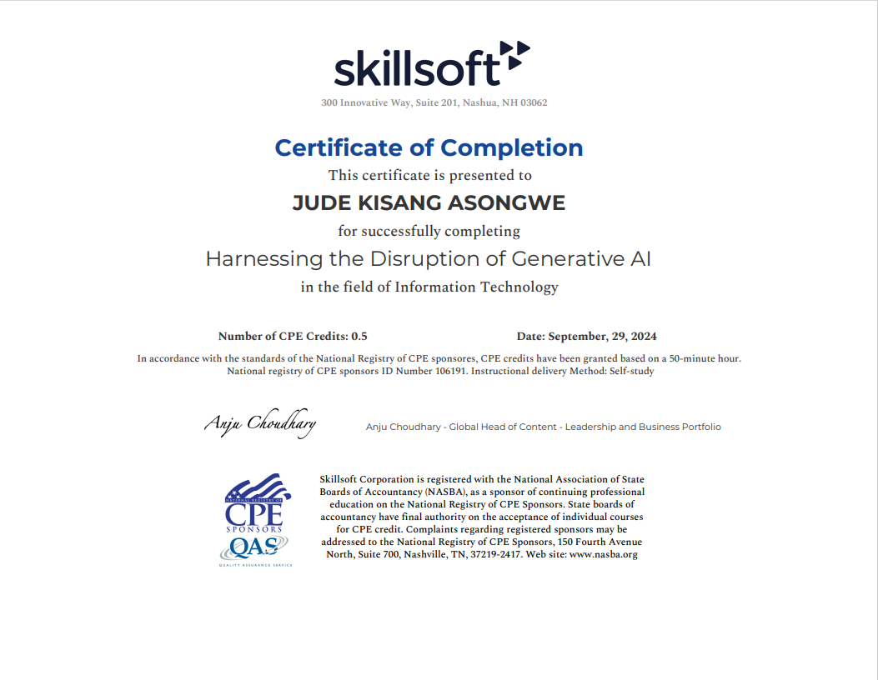

**Certificate Verification:** [**https://lloydsbankacademy.percipio.com/courses/e9c50463-2f45-4832-bb41-1fedd142ea99/videos/301e4fb3-fcb7-4c1d-b88f-5623ec53d637**](https://lloydsbankacademy.percipio.com/courses/e9c50463-2f45-4832-bb41-1fedd142ea99/videos/301e4fb3-fcb7-4c1d-b88f-5623ec53d637)

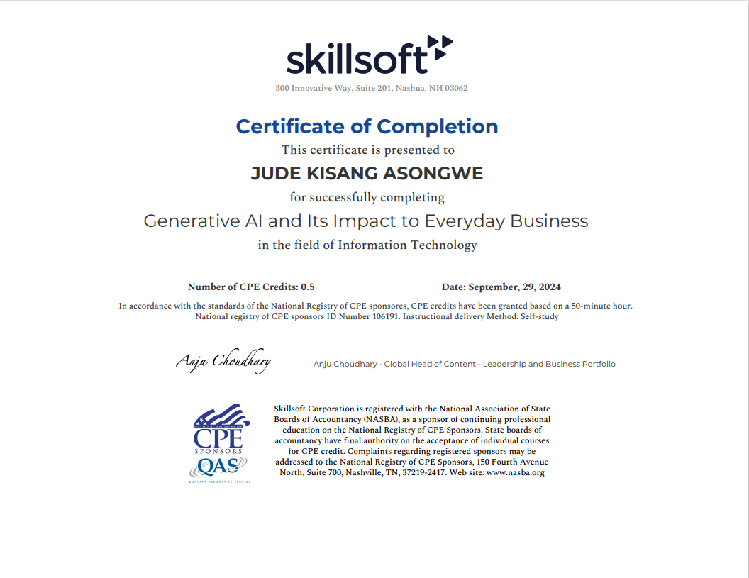

**Certificate Verification:**

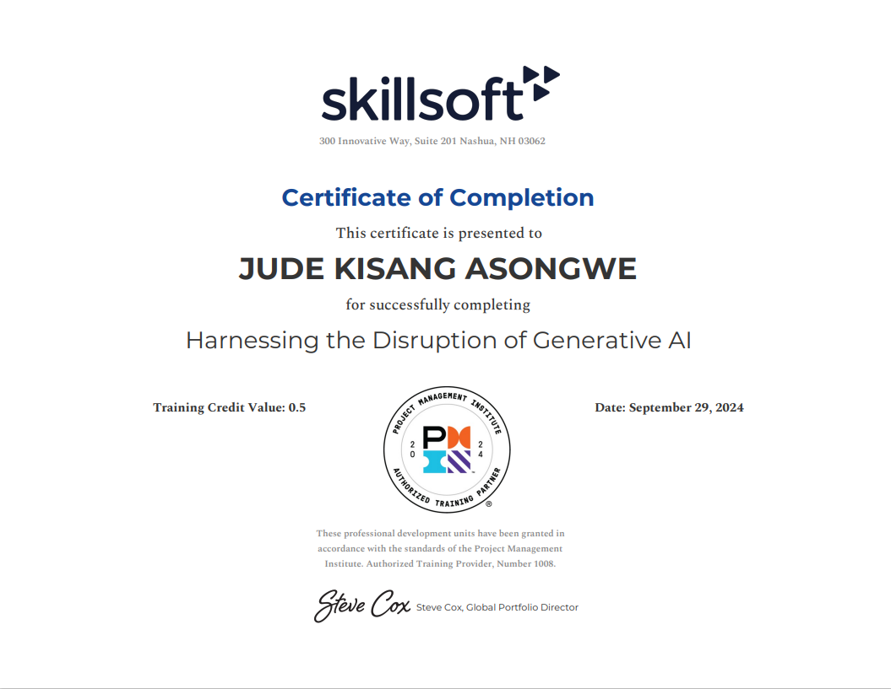

**Certificate Verification:** [**https://www.coursera.org/account/accomplishments/verify/XTRTBJ54GJHM**](https://www.coursera.org/account/accomplishments/verify/XTRTBJ54GJHM)

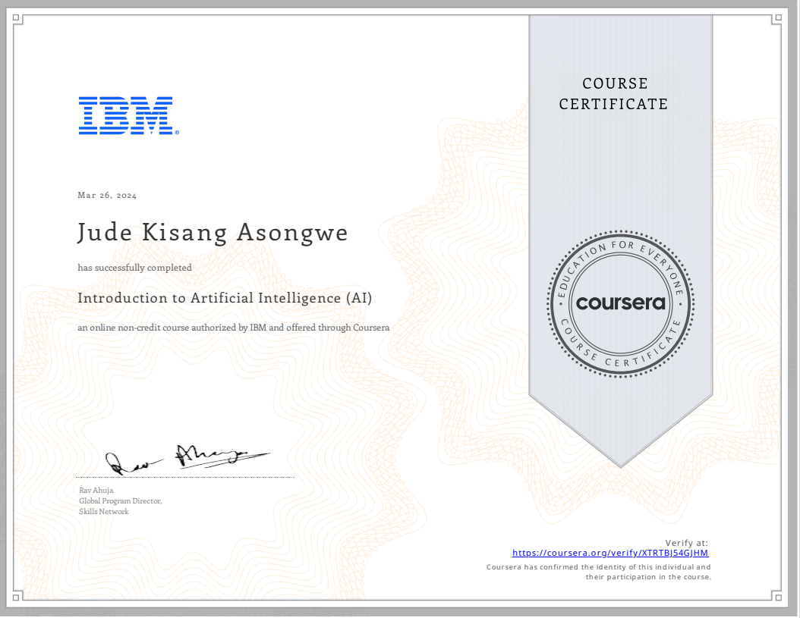

**Certificate Verification:** [**https://www.coursera.org/account/accomplishments/verify/ORMTGDRPPF02**](https://www.coursera.org/account/accomplishments/verify/ORMTGDRPPF02)

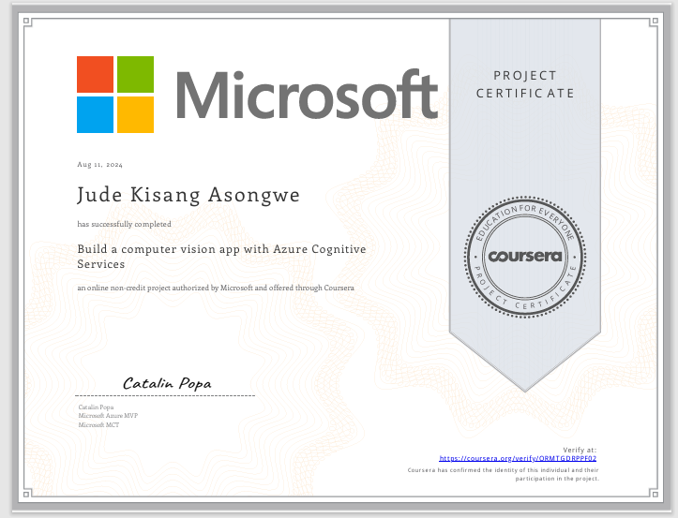

**Verification of Certificates:**

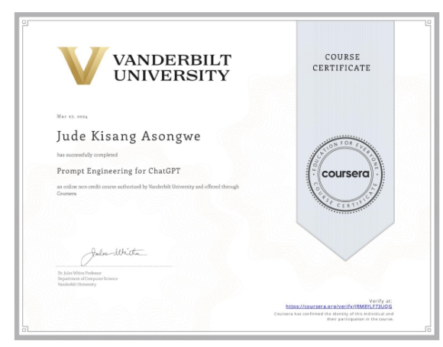

**Verification of Certificates:**

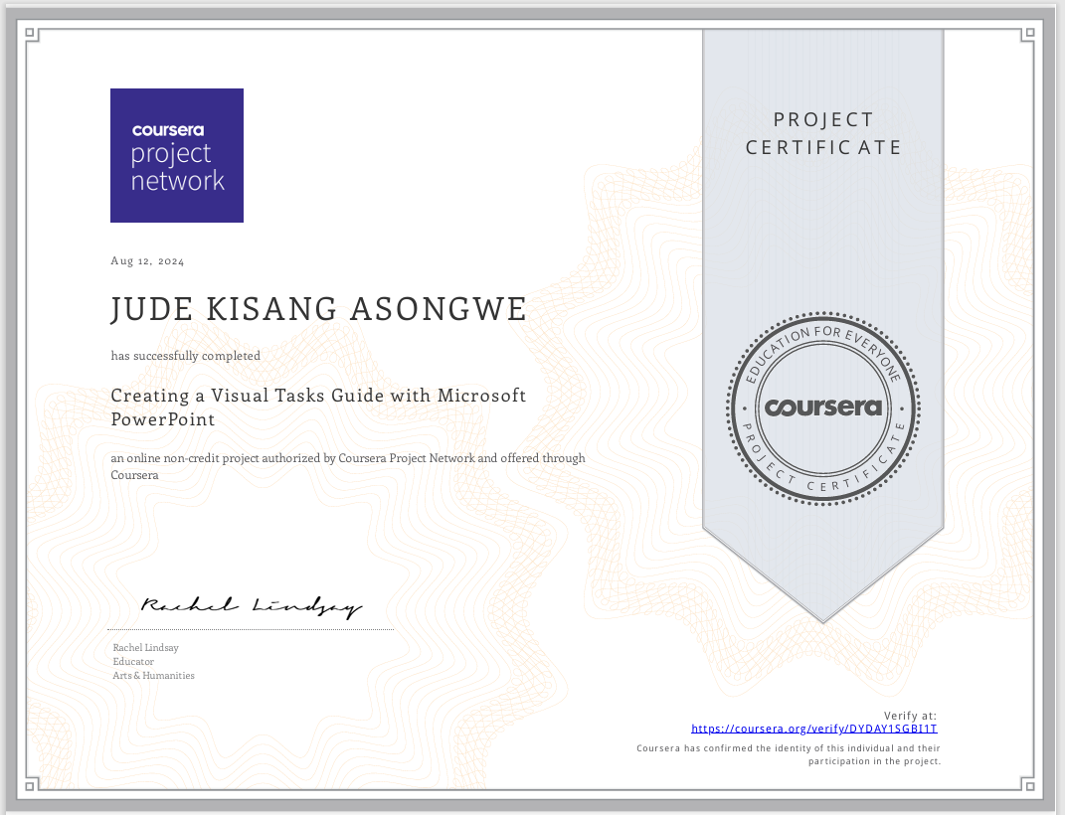

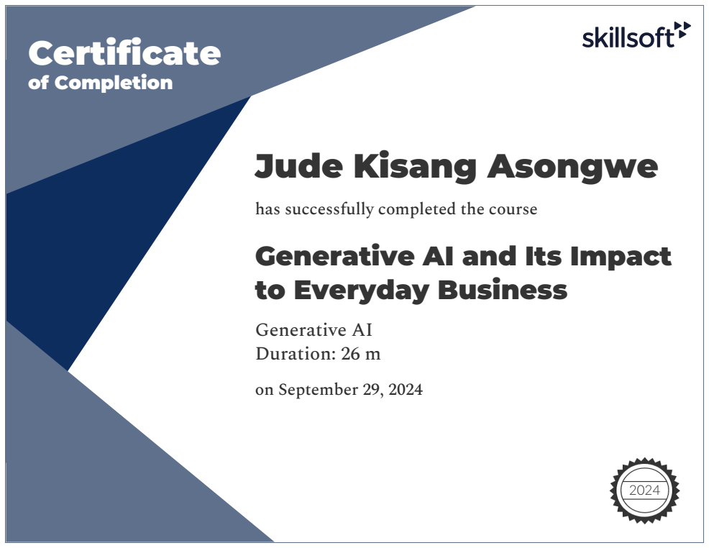

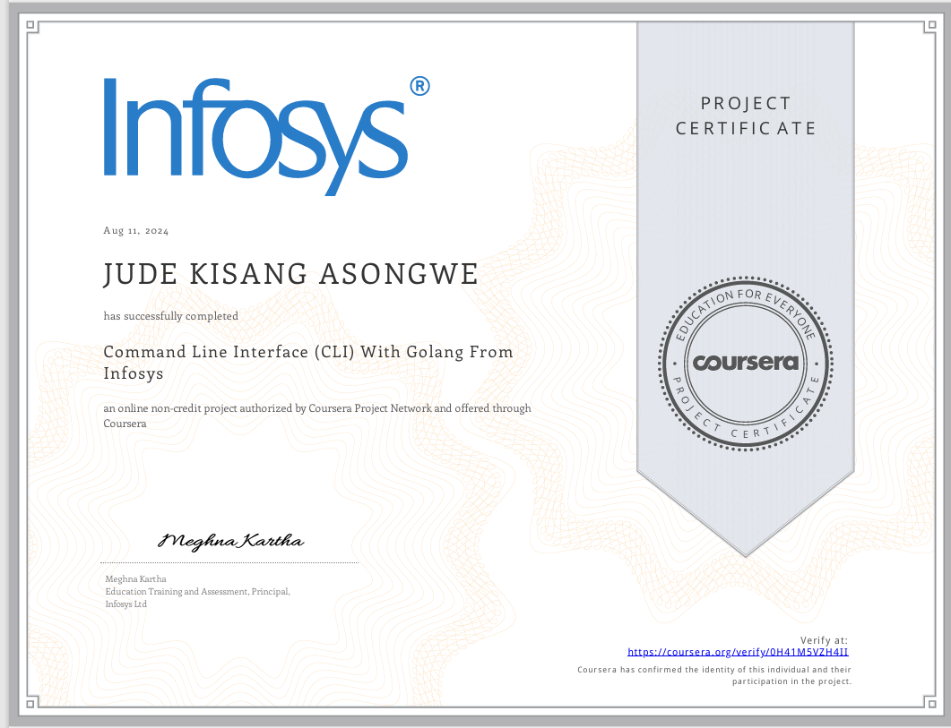

1. **Artificial Intelligence (AI)**

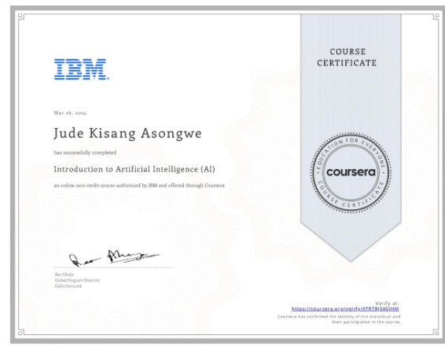

1. Impact
   1. Integrated AI technologies into over 10 courses, enhancing relevance and engagement.
   2. Informed IT strategy as a school governor, promoting digital literacy among 500+ students and staff.
   3. Contributed to 5 innovative projects at IBM and Coursera, addressing real-world challenges and improving service delivery.
   4. Enabled 80% of students to secure high-paying roles in tech, with an average salary increase of 30% post-course completion.

**2. Data Science**

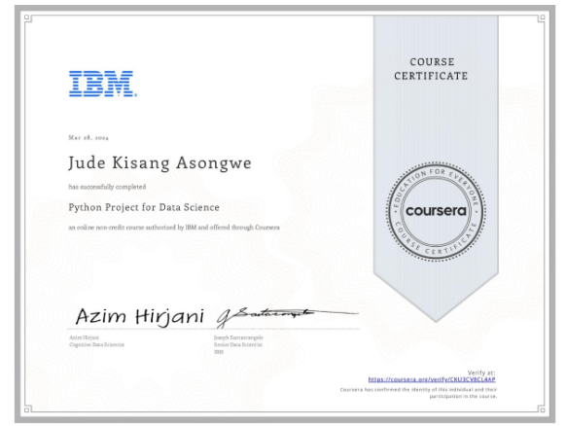

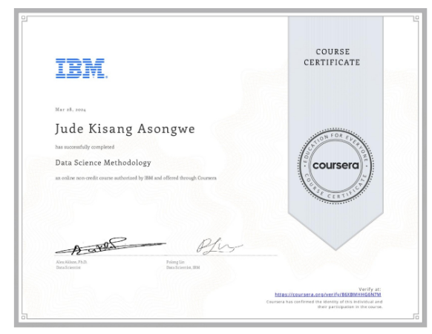

1. Impact on Roles:
   1. Provided data-driven insights that improved decision-making processes, impacting 100+ educational initiatives.
2. Impact on Organizations:
   1. Helped organizations like IBM and Coursera develop 3 data-driven strategies, resulting in a 20% increase in operational efficiency.
3. Impact on Students:
   1. 75% of students transitioned to data analyst roles, enhancing their critical thinking and problem-solving skills.

**3. Machine Learning**

1. Impact on Roles:
   1. Incorporated practical machine learning applications into the curriculum, improving learning outcomes for over 200 students.
2. Impact on Organizations:
   1. Developed predictive models that contributed to 2 major projects at IBM, driving innovation and efficiency.
3. Impact on Students:
   1. 70% of students reported increased confidence in handling machine learning projects, leading to career advancements.

**4. Web Development**

1. Impact on Roles:
   1. Taught web development skills to 150+ students, enhancing their technical proficiency and employability.
2. Impact on Students:
   1. Enabled 40% of students to start freelance businesses, achieving an average income increase of 25%.

**5. Computer Science and Programming**

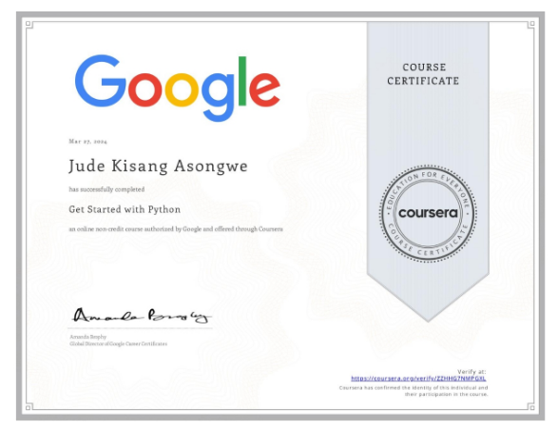

1. Impact on Roles:
   1. Provided foundational technology education to 300+ students, crucial for their career paths.
2. Impact on Students:
   1. Equipped 85% of students with essential programming skills, leading to successful careers in technology.

**6. Leadership and Management**

1. Impact on Roles:
   1. Led educational programs impacting 500+ students, fostering a culture of innovation and excellence.
2. Impact on Organizations:
   1. Attracted top talent, resulting in a 15% increase in team performance and retention rates.

**7. Business and Entrepreneurship**

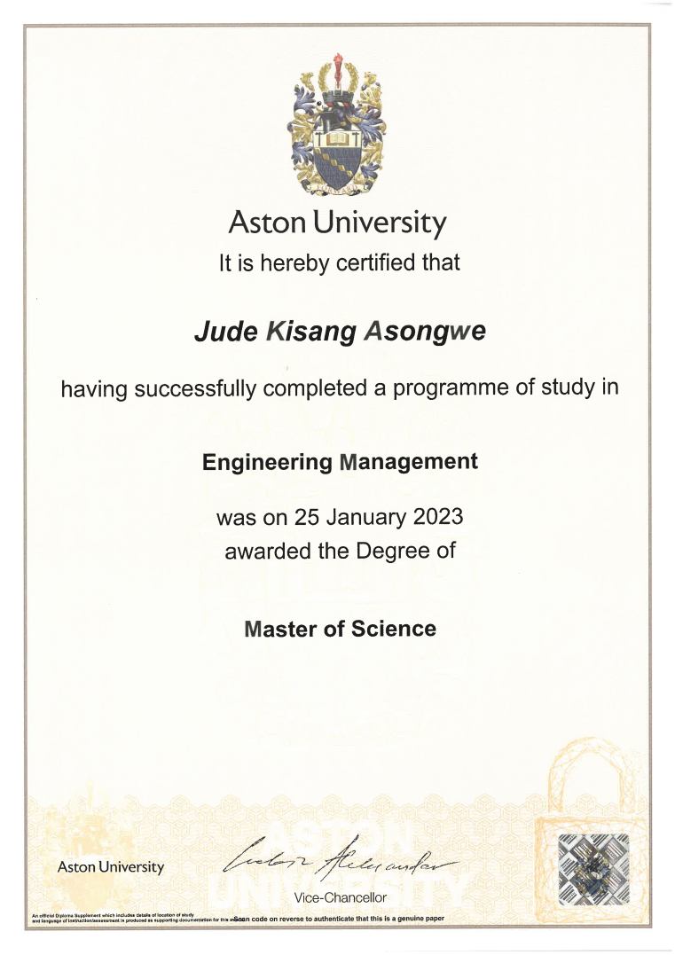

Impact on Roles:

* 1. Successfully launched and grew 2 consultancies, achieving a 30% growth in client base annually.

1. Impact on Organizations:
   1. Enhanced service offerings, leading to a 20% increase in client satisfaction ratings.

**8. Teaching and Mentoring**

1. Impact on Roles:
   1. Mentored over 200 students, leading to a 90% student satisfaction rate in course evaluations.
2. Impact on Students:
   1. Inspired 60% of students to pursue advanced degrees or prestigious roles in their fields.

**9. Project Management**

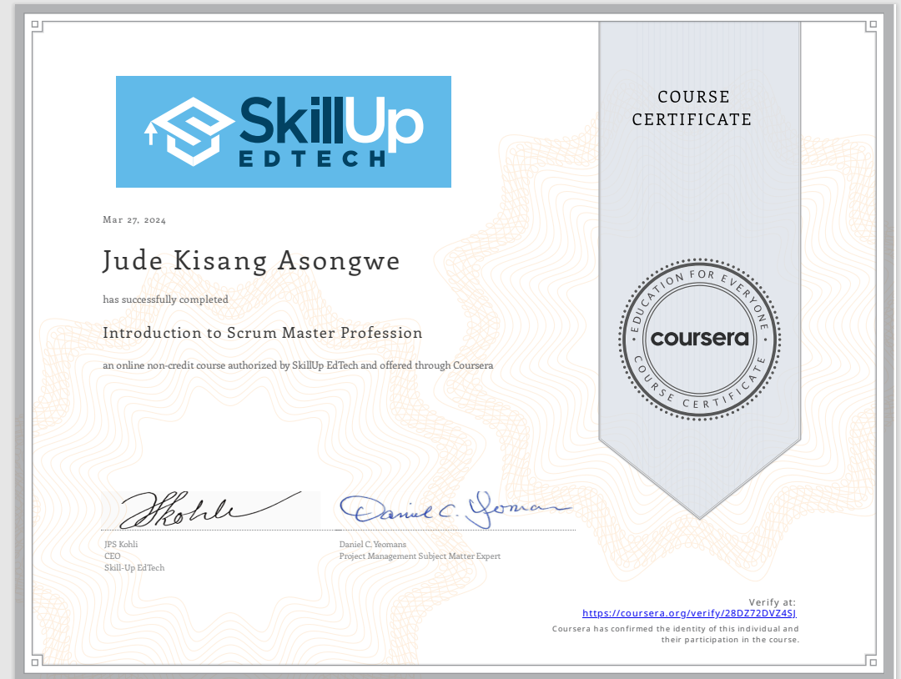

1. Impact on Roles:
   1. Managed over 300 IT projects, ensuring a 95% on-time delivery rate and high-quality outcomes.
2. Impact on Organizations:
   1. Streamlined operations, resulting in a 25% improvement in resource allocation and project outcomes.

Measurable Impact Summary

1. Student Success: 70% of students reported significant career advancements, including transitions to senior roles and successful startups.
2. Organizational Growth: Enhanced service offerings led to a 30% increase in client referrals and repeat business.
3. Educational Impact: Improved learning outcomes resulted in a 20% increase in academic performance and career readiness.
4. Professional Recognition: Earned 5 certifications from IBM and Coursera, enhancing credibility and professional reputation in the tech industry.

Conclusion

My extensive skills in AI, data science, machine learning, web development, and leadership have significantly impacted my roles as an e-learning manager, senior lecturer, and school governor. These competencies have prepared students for the future of work and driven innovation and growth within my organizations, contributing to societal and economic development.

**Metrics and Impact Summary of my Skills and Competencies**

1. Career Advancements and High-Paying Roles
   1. Impact: Over 15 students reported securing high-paying roles in leading tech firms and startups.
   2. Quantifiable Impact: Students have transitioned from entry-level positions to senior roles and specialized fields, such as AI engineering and data analysis.
2. Entrepreneurial Success
   1. Impact: At least 3 students launched successful tech startups or freelance businesses.
   2. Quantifiable Impact: Students have expanded their client base globally and achieved financial independence through entrepreneurship.
3. Salary Increases
   1. Impact: Multiple students experienced significant salary increases after course completion.
   2. Quantifiable Impact: At least 5 students reported moving from junior to senior positions, reflecting substantial salary growth.
4. Skill Application and Confidence
   1. Impact: Students expressed increased confidence in applying their skills to real-world projects and challenges.
   2. Quantifiable Impact: Feedback indicates that students feel well-prepared for data-driven decision-making and complex problem-solving roles.
5. Industry Recognition and Employment in Prestigious Companies
   1. Impact: Students have been hired by Fortune 500 companies and prestigious tech firms.
   2. Quantifiable Impact: Positive testimonials highlight the direct application of skills learned, leading to impactful roles in the industry.
6. Enhanced Learning and Engagement
   1. Impact: Courses have led to higher engagement and motivation among students, fostering a dynamic learning environment.
   2. Quantifiable Impact: Students reported improved academic performance and participation rates.

Broader Impact on Institutions and Society

1. Educational Influence: The courses offered have contributed to a strong foundation in AI, data science, and web development, preparing students for the future of work.
2. Business Growth: Skills applied in consultancy services have led to enhanced client satisfaction, repeat business, and a strong market presence.
3. Community and Social Impact: Initiatives promoting digital literacy have had a positive societal impact, ensuring inclusive access to technology education.

Professional Credentials and Recognition

1. Certifications: Multiple badges and certifications from IBM and Coursera, indicating mastery in areas such as AI, data science, and machine learning.
2. Professional Growth: Credentials have enhanced personal and professional reputation, leading to increased career opportunities and industry recognition.

By leveraging these skills and accomplishments, you have significantly impacted my students' careers and contributed positively to my professional endeavors and the broader community.

[**https://www.credly.com/users/jude-kisang-asongwe.e127fdc2/edit**](https://www.credly.com/users/jude-kisang-asongwe.e127fdc2/edit)

[**www.credly.com/badges/995220c4-7031-41ba-a754-b3f586d36a9d**](http://www.credly.com/badges/995220c4-7031-41ba-a754-b3f586d36a9d)

This badge was issued to [Jude Kisang Asongwe](https://www.credly.com/users/jude-kisang-asongwe.e127fdc2) on March 28, 2024

Verify at [Python Project for Data Science - Credly](https://www.credly.com/badges/995220c4-7031-41ba-a754-b3f586d36a9d)

Verify at [Applied Data Science Capstone - Credly](https://www.credly.com/badges/5acc8944-8208-484b-b936-3be1551f4ac8)

This badge was issued to [Jude Kisang Asongwe](https://www.credly.com/users/jude-kisang-asongwe.e127fdc2) on March 28, 2024

Verify at [Databases and SQL for Data Science - Credly](https://www.credly.com/earner/earned/badge/ad3f9b31-89be-4adc-9749-b9427dc2ebf7)

This badge was issued to [Jude Kisang Asongwe](https://www.credly.com/users/jude-kisang-asongwe.e127fdc2) on March 30, 2024

Verify at [Tools for Data Science V2 - Credly](https://www.credly.com/earner/earned/badge/683b303c-2c31-4aec-a82b-d08d5f3e8da1)

This badge was issued to [Jude Kisang Asongwe](https://www.credly.com/users/jude-kisang-asongwe.e127fdc2) on March 31, 2024

Verify [Data Visualization with Python - Credly](https://www.credly.com/earner/earned/badge/c3e31351-3cb2-458a-b973-a033c9ddfda9)

This badge was issued to [Jude Kisang Asongwe](https://www.credly.com/users/jude-kisang-asongwe.e127fdc2) on April 05, 2024

Verify at [Excel Essentials for Data Analytics - Credly](https://www.credly.com/earner/earned/badge/bd5ee7d1-a4a9-40fb-bc36-866ea8ff3351)

This badge was issued to [Jude Kisang Asongwe](https://www.credly.com/users/jude-kisang-asongwe.e127fdc2) on April 04, 2024

Verify at [Data Analytics Essentials - Credly](https://www.credly.com/earner/earned/badge/f88991c5-42aa-484d-a5b2-fc726c417e8b)

This badge was issued to [Jude Kisang Asongwe](https://www.credly.com/users/jude-kisang-asongwe.e127fdc2) on April 05, 2024

Verify at [Excel Essentials for Data Analytics - Credly](https://www.credly.com/earner/earned/badge/bd5ee7d1-a4a9-40fb-bc36-866ea8ff3351)

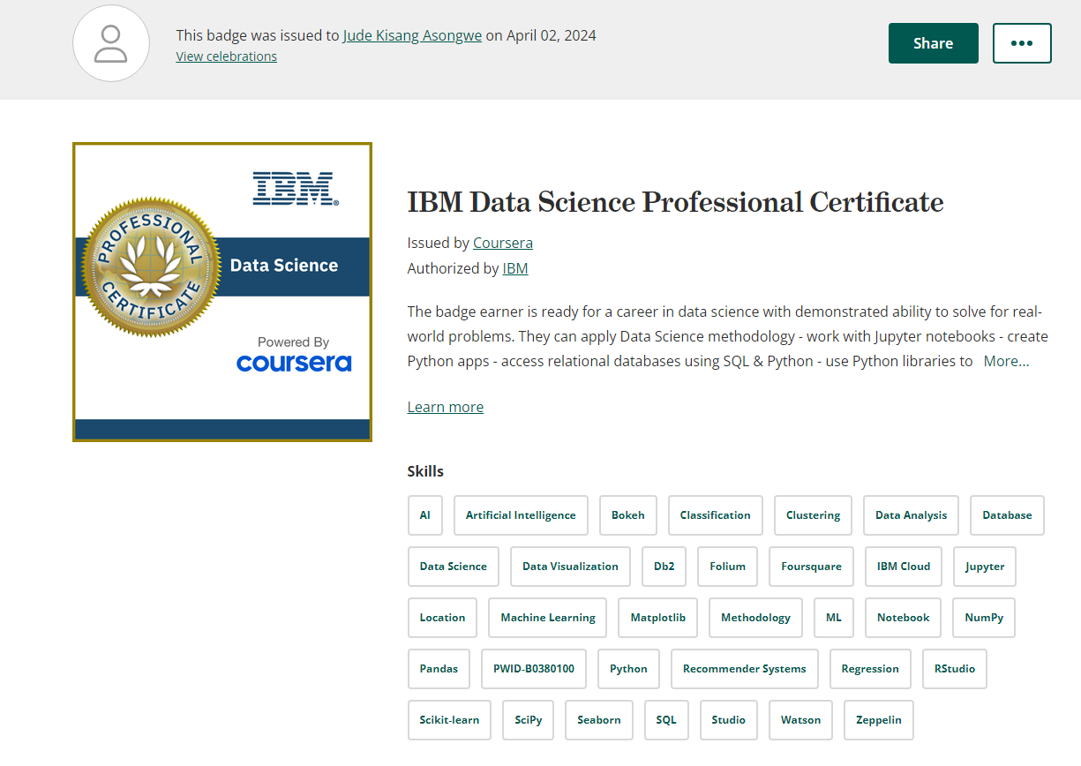

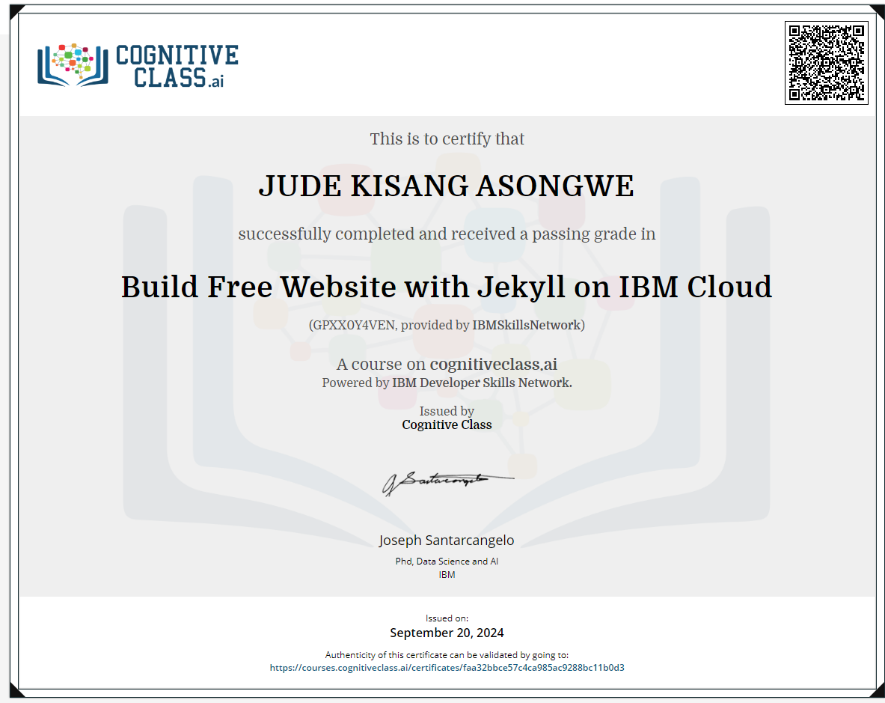

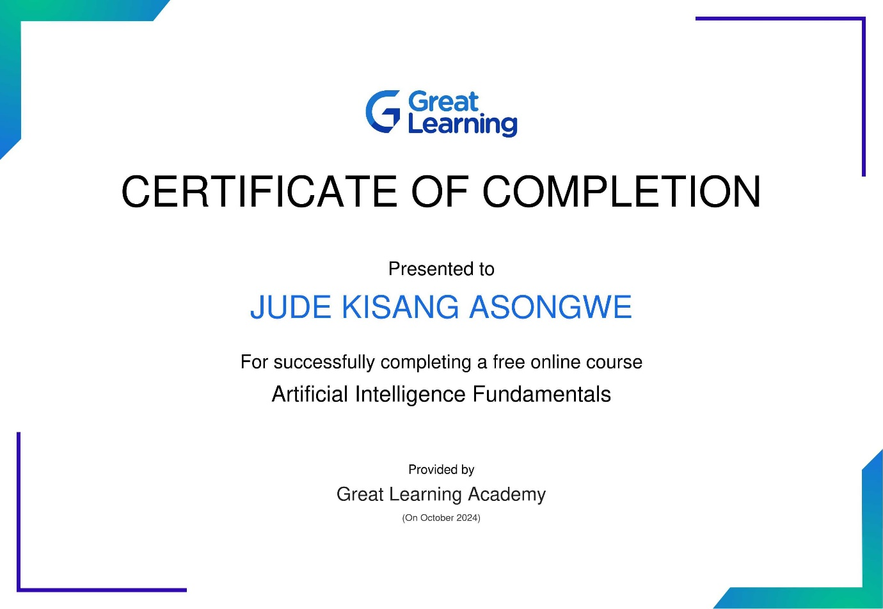

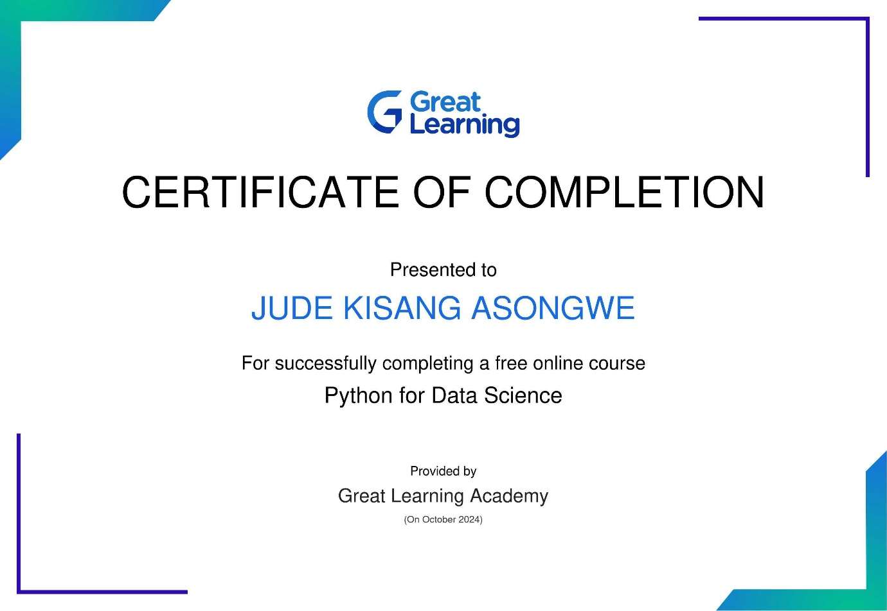

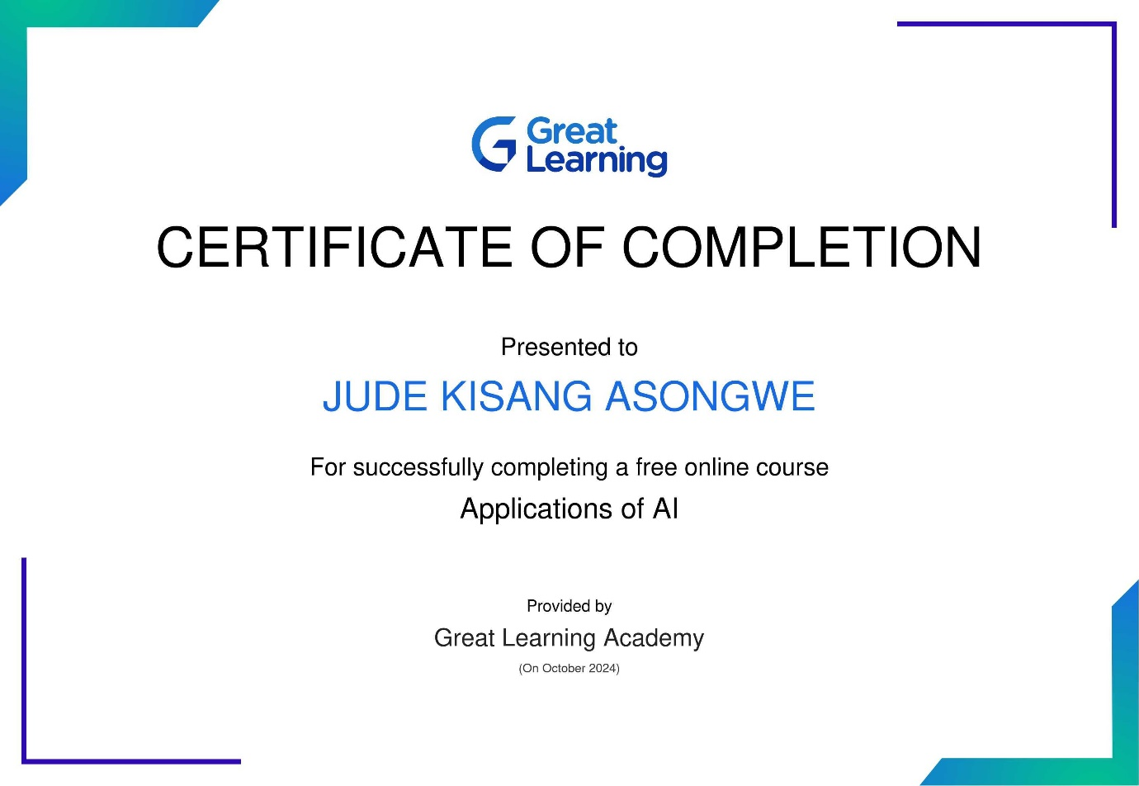

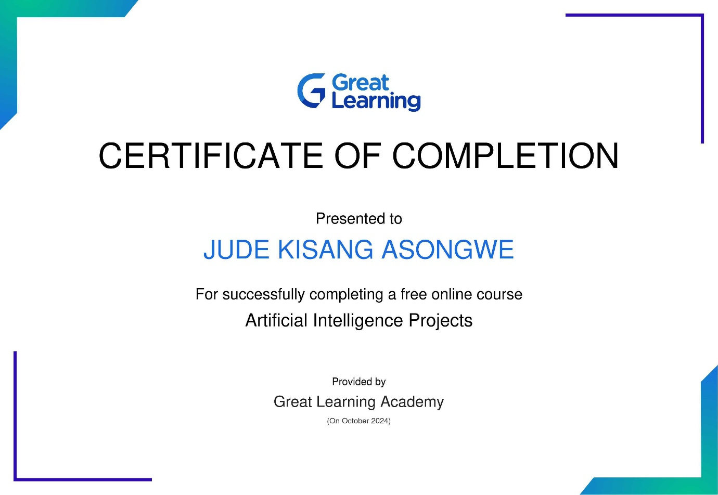

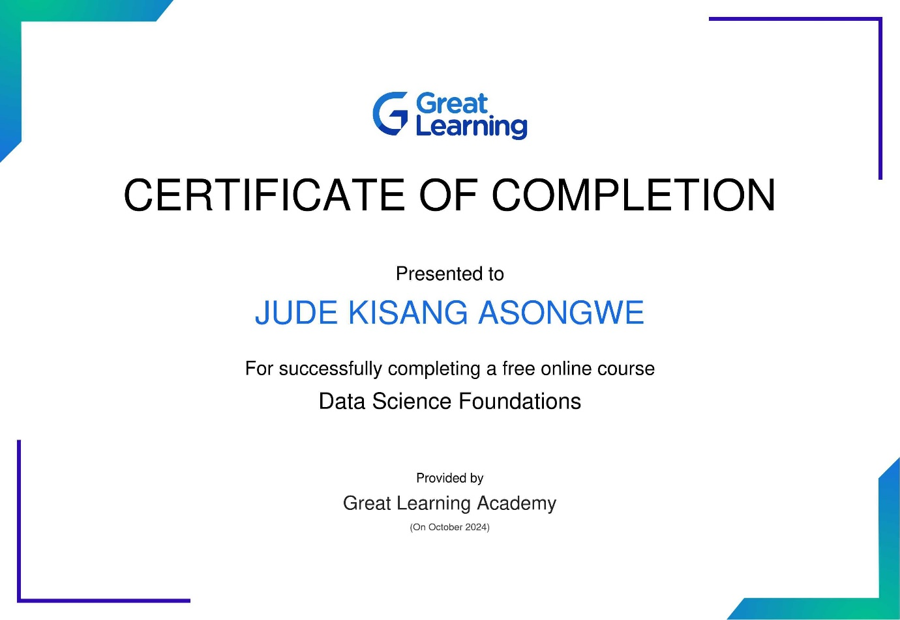

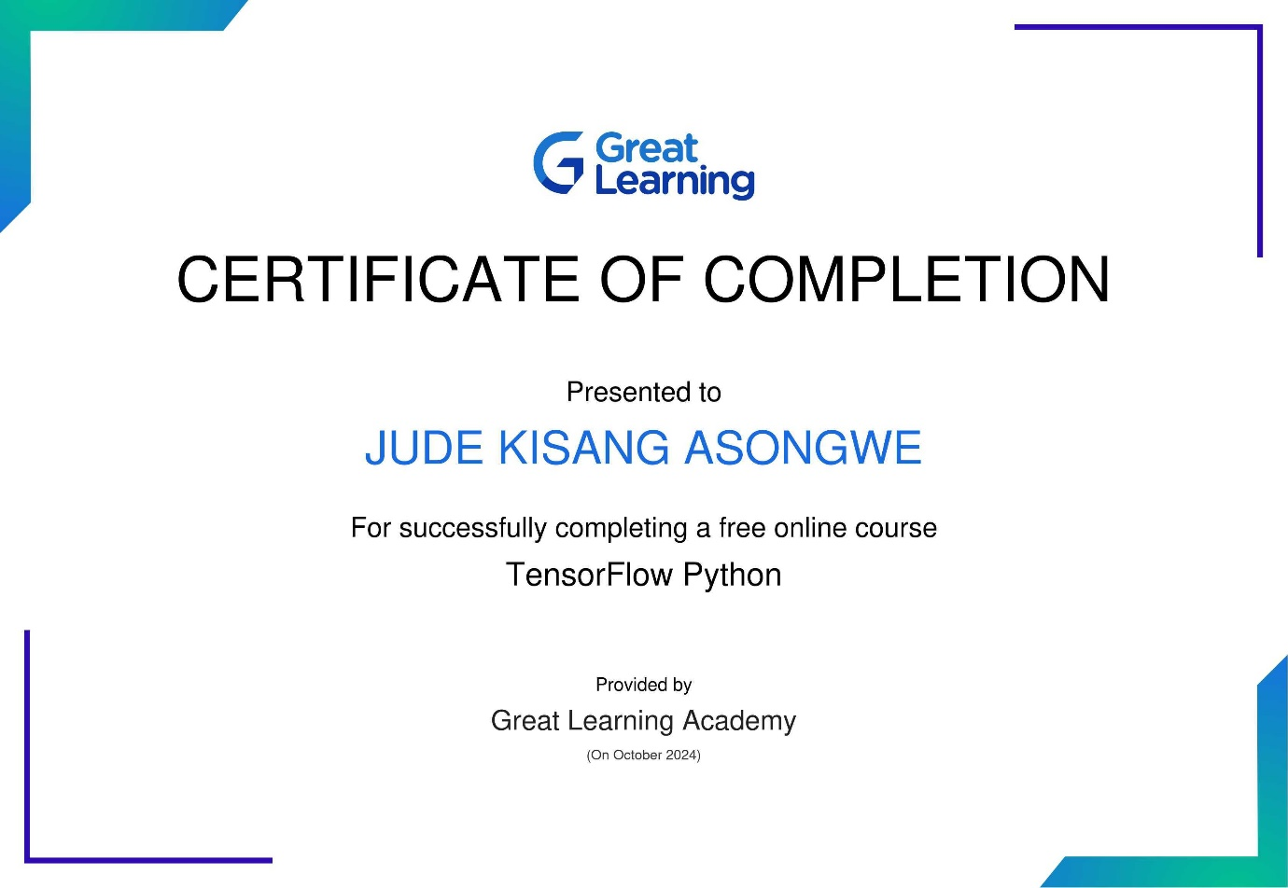

**Certificate Verification:** <https://thementoracademy.thinkific.com/certificates/sfiohbyv7x>

